Web Design and Development

4COSC011W

Report

Author : Ilsara Malavi PathirageStudent ID : w1867461Group Number : E - 8Student Role : Student 2

Link to Web Site URL:

https://w1867461.users.ecs.westminster.ac.uk/

Content

1. Introduction 2

* 1. Topic of the website …………………………………………………………………….3
  2. Group members …………………………………………………………………………3
  3. Group meetings …………………………………………………………………………4

2. Technical Discussion 4

2.1 Main Site navigation Bar …………………………………………………………...…..6

2.2 External CSS …………………………………………………………………………….7

2.3 Query form ……………………………………………………………………...…..….. 9

2.4 Main Page ………………………………………………………………...……………12

2.5 Page Editor page ………………………………………………………………….…..16

2.6 Tours Page (Extra content page) ……………………………………………..……..16

3. Webpage Validation Statement 18

4. Janet 18

5. References 18

6. Appendices 19

6.1 Appendix A: Code 20

6.2 Appendix B: Screenshots 62

6.3 Appendix C: Screenshots: Webpage Validation Evidence 71

6.4 Appendix D: Individual Statement 74

# Introduction

* 1. **Topic of the website**
* Tourism
  1. **Group members**

**Student 1** - Kavithma Ganguli (w1867456 - 20210369)

* Presentaion Page
* Buy Products

**Student 2** - Ilsara Pathirage (w1867461 - 20210378)

* Main Page
* Query Form

**Student 3** - Kamil Thenuwara (w1867087 - 20210331)

* Quiz
* Student Details

**Student 4** - Bimali Tissera (w1867096 - 20210337)

* SVG Diagram
* Thumbnail Images
  1. **We had our group meetings as follows,**

| **Group Coursework Meetings** | | |
| --- | --- | --- |
| **1** | **Date & Time** | **5th March 2022 (online)** |
| **Objective:** | **To decide a topic and assign student roles** |
| **Attended:** | **All students attended** |
| **Your Contribution:** | **I suggested Tourism and Art Topics as my options** |
| **2** | **Date & Time:** | **7th March 2022 (online)** |
| **Objective:** | **Created a wireframe** |
| **Attended:** | **All students attended** |
| **Your Contribution:** | **I suggested creating our wireframe using ‘figma’ software and start working on it** |
| **3** | **Date & Time:** | **8th March 2022 (online)** |
| **Objective:** | **Created a wireframe** |
| **Attended:** | **All students attended** |
| **Your Contribution:** | **Finished Wireframe** |
| **4** | **Date & Time:** | **12th March 2022 (online)** |
| **Objective:** | **Created server URL** |
| **Attended:** | **All students attended** |
| **Your Contribution:** | **Created UOW FTP server link** |
| **5** | **Date & Time:** | **15th March 2022 (online)** |
| **Objective:** | **Home page** |
| **Attended:** | **All students attended** |
| **Your Contribution:** | **Started to create Home page** |
| **6** | **Date & Time:** | **18th March 2022 (online)** |
| **Objective:** | **Basic HTML and CSS structure** |
| **Attended:** | **All students attended** |
| **Your Contribution:** | **Design of the Navigation Bar** |
| **7** | **Date & Time:** | **22nd March 2022 (online)** |
| **Objective:** | **Created Logo and editors pages** |
| **Attended:** | **All students attended** |
| **Your Contribution:** | **I suggested logo design and start creating using photoshop** |
| **8** | **Date & Time:** | **23rd March 2022 (online)** |
| **Objective:** | **HTML and CSS structure JavaScript** |
| **Attended:** | **All students attended** |
| **Your Contribution:** | **Shared Navigation bar with team members** |

| **9** | **Date & Time:** | **25th March 2022(Online)** |
| --- | --- | --- |
| **Objective:** | **Additional page** |
| **Attended:** | **All students attended** |
| **Your Contribution:** | **I suggested creating additional page of tours in Sri Lanka** |
| **10** | **Date & Time:** | **27th March 2022(Online)** |
| **Objective:** | **Finalized all pages and validation part** |
| **Attended:** | **All students attended** |
| **Your Contribution:** | **Shared all the pages and connected each pages together.** |

# 

# Technical Discussion

I’m Ilsara Pathirage and I’m the leader of the group E - 8 for the Web Design and Development coursework. We took the topic “ Tourism ” and the name of our web site is “ Serendib Tours ”.

The parts allocated to student 1 are Home page, Query Page and Navigation bar.

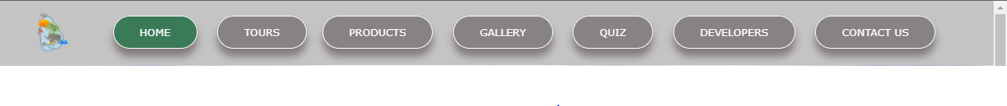**2.1 Main Site navigation Bar**

The top of every page has the navigation bar with website logo displayed in left side and useful links which user can access several parts of the website easily. This navigation Bar contain hover effects and link becomes active and colour changes when user click on it. Main web pages of the ‘Serendib Tours’ displayed on the navigation bar.

CSS can be used to transform plain HTML menus into visually appealing navigation bars.For the Navigation bar I used #C4C4C4 colour background bar and I placed navigation bar on it because to give more eye-catch to the user. display: inline-block used to make the list horizontal. I apply padding and margin properties to create space between elements, and defined borders. I used text-decoration = none property to remove the underline name in all the navigation buttons. Border-radius used to curve the navigation buttons edges and also, I used different colours to hover and action activity. I apply box-shadow property to give more attractivity to the navigation bar and it shows shadow to each button.

**HTML:**

<section class="Navigation_Bar">

<nav class="links">

<a href="Home.html"><img class="logo" src="./images/logo.png" alt="logo" ></a>

<div class="Navigation_links" id="navLinks">

<ul>

<li><a href="Home.html" class="active">HOME</a></li>

<li><a href="tours.html ">TOURS</a>

<li><a href="products.html">PRODUCTS</a></li>

<li><a href="gallery.html">GALLERY</a></li>

<li><a href="start.html">QUIZ</a></li>

<li><a href="studentdetail.html">DEVELOPERS</a></li>

<li><a href="query.html">CONTACT US</a></li>

</ul>

</div>

</nav>

</section>

**CSS:**

/* Naviagtion Bar */

.Navigation_links .active {

border: 1px solid white;

color: white;

background-color: #3b7a57;

}

.Navigation_links ul li {

display: inline-block;

padding: 10px 10px 10px 10px;

position: relative;

}

.Navigation_links ul li a {

color: #fff;

font-size: 13px;

text-decoration: none;

cursor: pointer;

color: rgb(255, 255, 255);

border: 1px solid white;

padding: 12px 33px;

background: #888383;

position: relative;

transition: 1s;

border-radius: 50px;

box-shadow: 0 10px 10px rgba(65, 47, 47, 0.5);

}

.Navigation_links ul li a:hover {

border: 1px solid #ffffff;

background: #404040;

color: white;

}

**2.1 External CSS**

We used same CSS styles for all the other pages to maintain the consistency of our webpage.

For that I shared my navigation styles with all the team members. For the home page as well as buy products page, quiz page, gallery, query page and extra page created for our tours we used same border-radius to curve the buttons and text boxes. And also, we discussed to use same hover effects and box-shadow property to keep the consistency throughout the website. We used curve edged images instead of common images.

Every page contains ‘Bottom to top’ button and we used same CSS effects on ‘Bottom to Top’ button in all the pages. It has hover effects and ‘^’ icon we got from ‘fontawesome’ website, when user clicks on the button automatically, he/she go to the top of the page smoothly.

**CSS:**

.button {

display: inline-block;

text-decoration: none;

color: white;

border: 1px solid #fff;

padding: 12px 34px;

font-size: 13px;

font-weight: bold;

background-color: #888383;

position: relative;

cursor: pointer;

transition: 1s;

border-radius: 50px;

box-shadow: 0 10px 10px rgba(65, 47, 47, 0.8);

}

/* hover */

.button:hover {

border: 1px solid #ffffff;

background: #404040;

color: white;

}

/* Back To Top */

.arrow_up{

height: 40px;

width:40px;

text-align: center;

background: #ffc40c;

cursor: pointer;

position: fixed;

bottom: 70px;

right: 30px;

z-index: 99;

border: none;

outline: none;

line-height: 39px;

color:black;

border-radius: 15px;

background-color: rgba(255,196,12,0.7);

}

.arrow_up:hover {

background-color: rgb(255,196,12);

}

html {

scroll-behavior: smooth;

}

**2.3 Query Form**

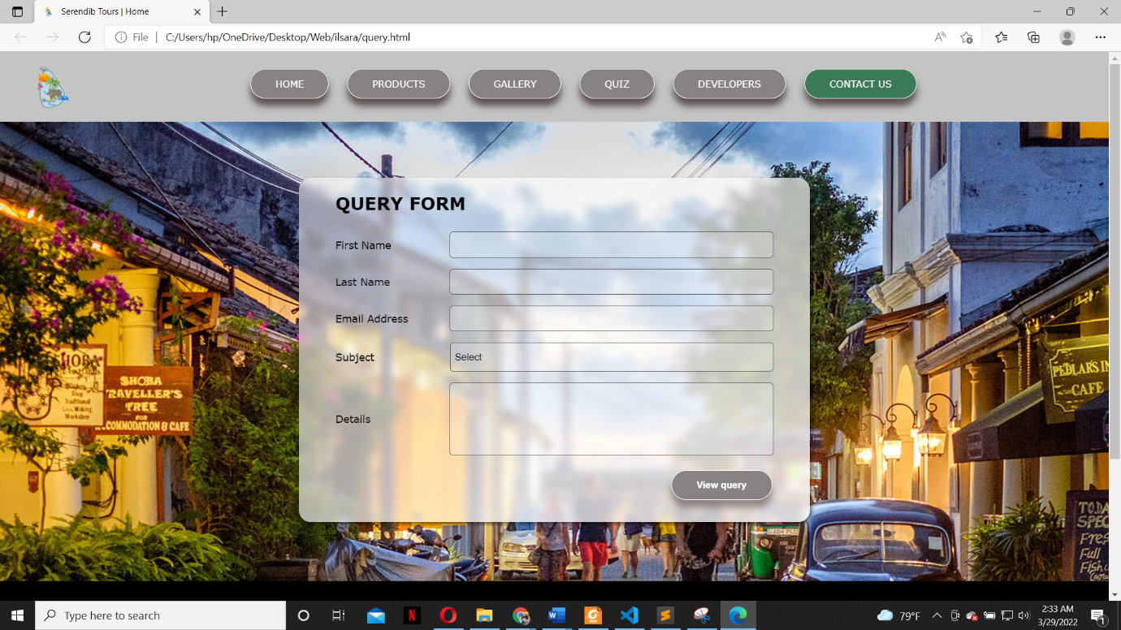

When user click on the contact us button in the navigation bar user redirect into the page called Query page. Query form used to send a query related to website content. This query form consist with two text input fields, one email input, four drown down menu list and text area. When the ‘view query’ button clicked ‘validateForm’ function activated and check that user has filled-in the compulsory fields like first name, last name, email, subject and details using JavaScript. If these compulsory fields are not filled pop up message will show to the user that field should be filled. And also ‘emailRangeCheck’ used to check that user entered email is valid. Otherwise, user can’t view the query details.

**HTML:**

<div class="query_input">

<label for="fname">First Name</label>

<input type="text" class="form_input" name = "First name" id="fname">

</div>

**JavaScript:**

function validateForm() {

var fname = document.getElementById("fname").value;

var lname = document.getElementById("lname").value;

var email = document.getElementById("email").value;

var details = document.getElementById("details").value;

var subject = document.getElementById("subject").value;

var emailRangeCheck = /^(([^<>()[\][\\.,;:\s@"]+(\.[^<>()[\]\\.,;:\s@"]+)*)|(".+"))@((\[[0-9]{1,3}\.[0-](file:///\\.,;:\s@%22%5d+(\.%5b%5e%3c%3e()%5b\%5d\\.,;:\s@%22%5d+)*)|(%22.+%22))@((\%5b%5b0-9%5d%7b1,3%7d\.%5b0-) 9]{1,3}\.[0-9]{1,3}\.[0-9]{1,3}\])|(([a-zA-Z\-0-9]+\.)+[a-zA-Z]{2,}))$/

if (fname == "" ) {

alert ("Please enter your First Name");

return false;

}

if (lname == "" ) {

alert ("Please enter your Last Name");

return false;

}

if (email == "" ) {

alert ("Please enter your Email");

return false;

}

if(!emailRangeCheck.test(email)){

alert ("Please enter a valid Email");

return false;

}

if (subject == "") {

alert ("Please select a subject");

return false;

}

if(details == "" ) {

alert ("Please enter details");

return false;

}

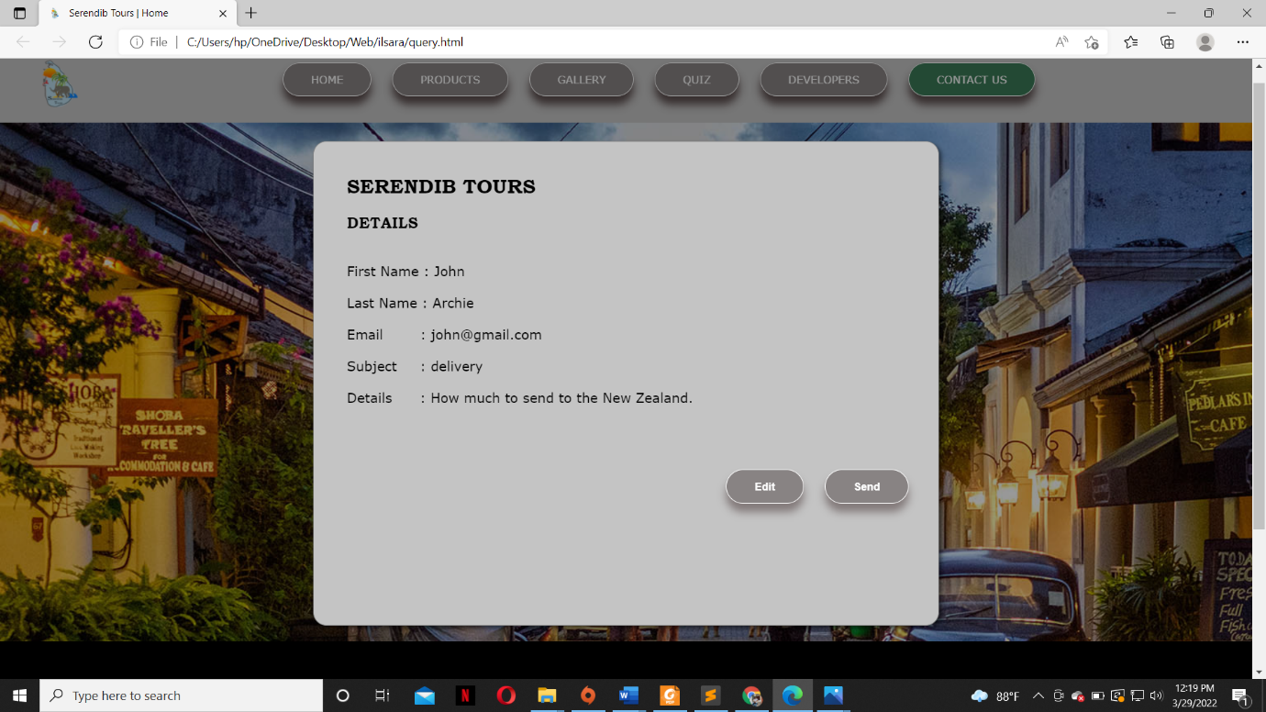

After user filled all the details correctly and click on the ‘view query’ button form disappears and user can see a display with all the details to check again before submit. If user wants to change anything he/she can click on ‘Edit’ button and this is replaced with the initial form which reappears with information filled in. Otherwise, user can click ‘Send’ button to submit the query via email and displayed details will disappear.

**JavaScript:**

var detail_box = document.getElementById("getdetail");

var btn = document.getElementById("view");

var span = document.getElementsByClassName("edit")[0];

btn.onclick = function() {

detail_box.style.display = "block";

}

span.onclick = function() {

detail_box.style.display = "none";

}

window.onclick = function(event) {

if (event.target == detail_box) {

detail_box.style.display = "none";

}

}

document.getElementById("deta").innerHTML="First Name : "+fname+"<br><br>"+"Last Name : "+lname+"<br><br>"+"Email: "+email+"<br><br>"+"Subject: "+subject+"<br><br>"+"Details: "+details;

document.getElementById("view").click();

}

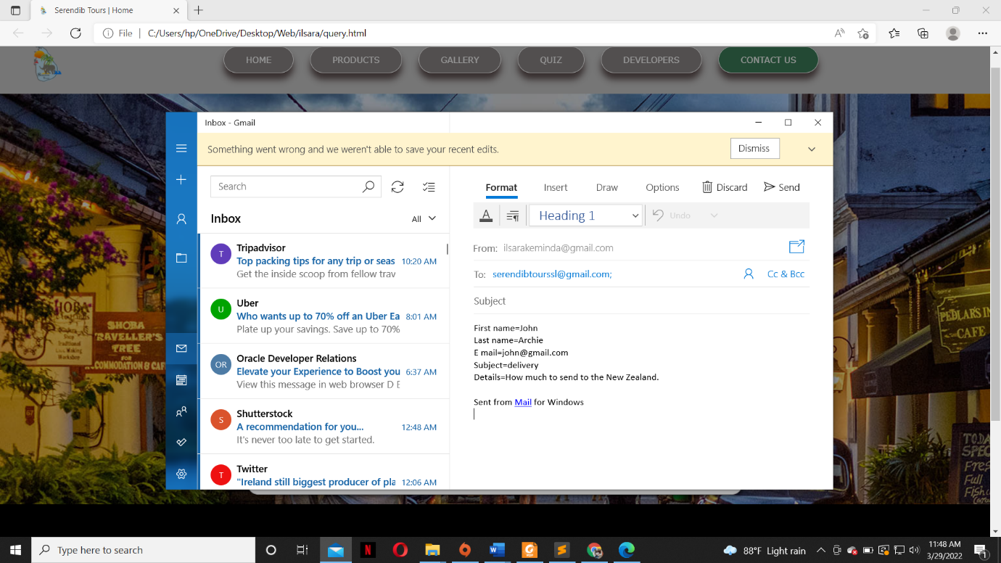

When user click on submit button mail app will open and it’ll fetch all the information filled in the query form. It will be sent to [serendibtourssl@gmail.com](mailto:serendibtourssl@gmail.com) automatically via your email app.

**2.4 Main Page**

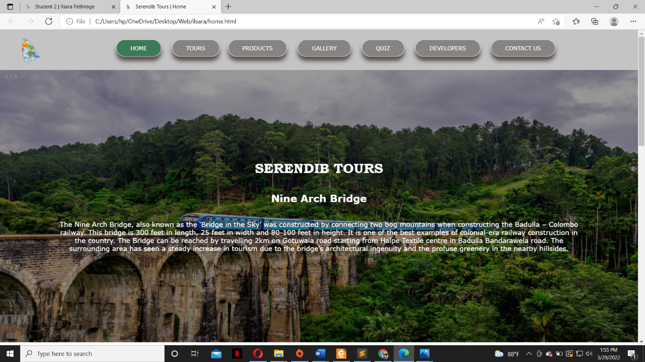

When the website loads after the presentation page, this is the first glance. The top of the webpage includes a navigation bar with the website logo displayed on the left side and useful links that allow users to easily access various parts of the website.

After the navigation bar user can see slideshow with six images. These images are tourist attractions places in Sri Lanka. For the slideshow images also have hover effect which will show ‘Serendib Tours’, the place of the image and a small description about that place.

**HTML:**

<div class="Slides fade">

<div class="num">4 / 6</div>

<img src="./images/yala.jpg" alt="Yala National Park" class="slides">

<div class="overlay">

<div class="slidetext">

<h1 class="topic">SERENDIB TOURS</h1><br><br><h2>Yala National Park</h2><p><br><br>Yala combines a strict nature reserve with a national park. Divided into 5 blocks.Among its more famous residents are the world’s biggest concentration of leopards, majestic elephants, sloth bears, sambars, jackals, spotted dear, peacocks, and crocodiles. The best time to visit Yala is between February and July when the water levels of the park are quite low, bringing animals into the open. </p>

</div>

</div>

</div>

**CSS:**

/* slides hover */

.slideshow_container {

position: relative;

width: 100%;

}

.slides {

display: block;

width: 100%;

height: auto;

max-height: 650px;

}

/* slides over transition*/

.overlay {

position: absolute;

top: 0;

bottom: 0;

left: 0;

right: 0;

height: 100%;

width: 100%;

opacity: 0;

transition: .7s ease;

background-color: rgba(0,0,0,0.4);

}

.slideshow_container:hover .overlay {

opacity: 1;

}

/* slides over words */

.slidetext {

color: white;

position: relative;

padding: 0 130px;

text-align: center;

top: 50%;

left: 50%;

-webkit-transform: translate(-50%, -50%);

-ms-transform: translate(-50%, -50%);

transform: translate(-50%, -50%);

}

**JavaScript:**

/* Slideshow */

var slideIndex = 0;

showSlides();

function showSlides() {

var i;

var slides = document.getElementsByClassName("Slides");

var dots = document.getElementsByClassName("bullets");

for (i = 0; i < slides.length; i++) {

slides[i].style.display = "none";

}

slideIndex++;

if (slideIndex > slides.length) {slideIndex = 1}

for (i = 0; i < dots.length; i++) {

dots[i].className = dots[i].className.replace(" active", "");

}

slides[slideIndex-1].style.display = "block";

dots[slideIndex-1].className += " active";

setTimeout(showSlides, 4000); // Change image every 4 seconds

}

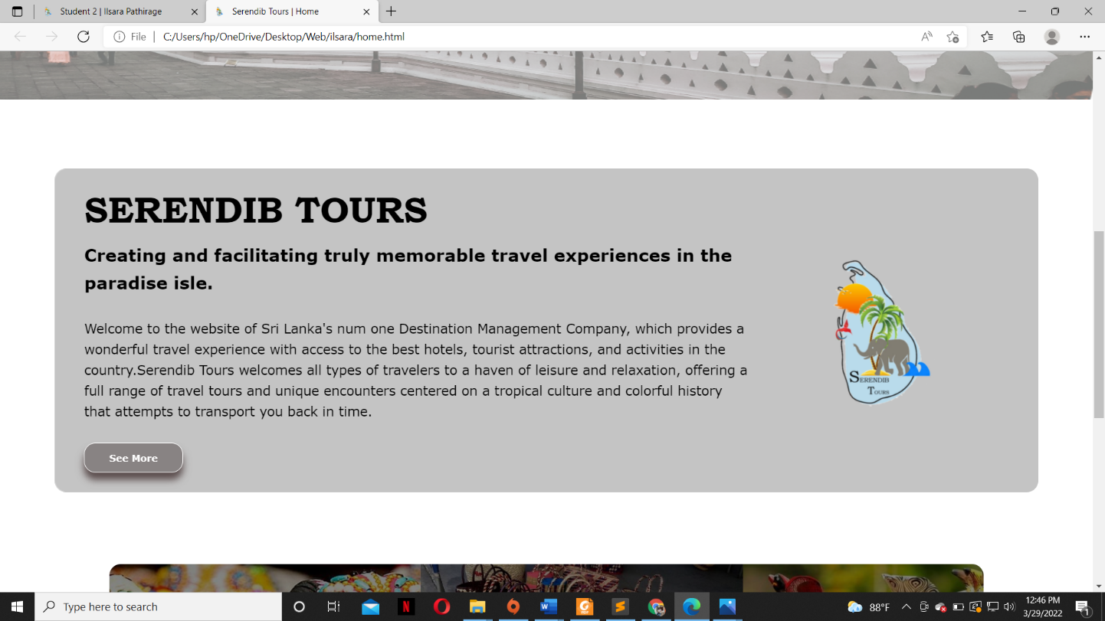

This is a breif description about out website and what are our services. Right side of the description we displayed our logo. Bottom of the box there is a button called ‘See more’ and it also have hover effects. When user clicks on that button he/she redirect into the tours page which we provide three tours around the country.

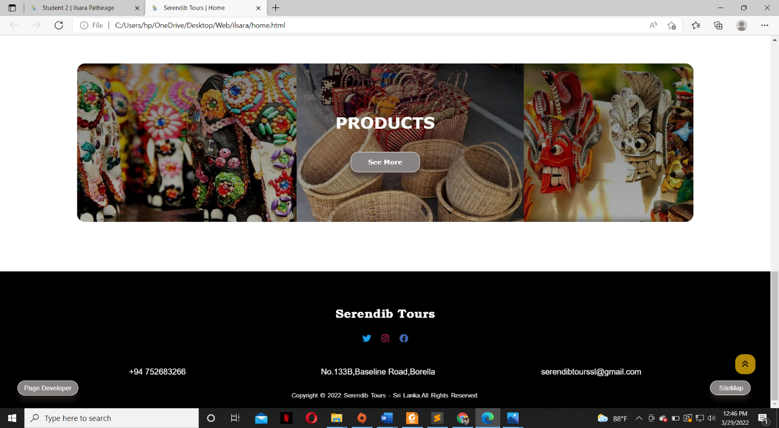

This box shows the image of products we selling like cane baskits,traditonal masks etc. There is also button called ‘See more’ and when user clicks on the button it redirect into ‘buyproducts’ page. This ‘See more’ button has hover effect which will turn into dark grey colour when mouse goes over.

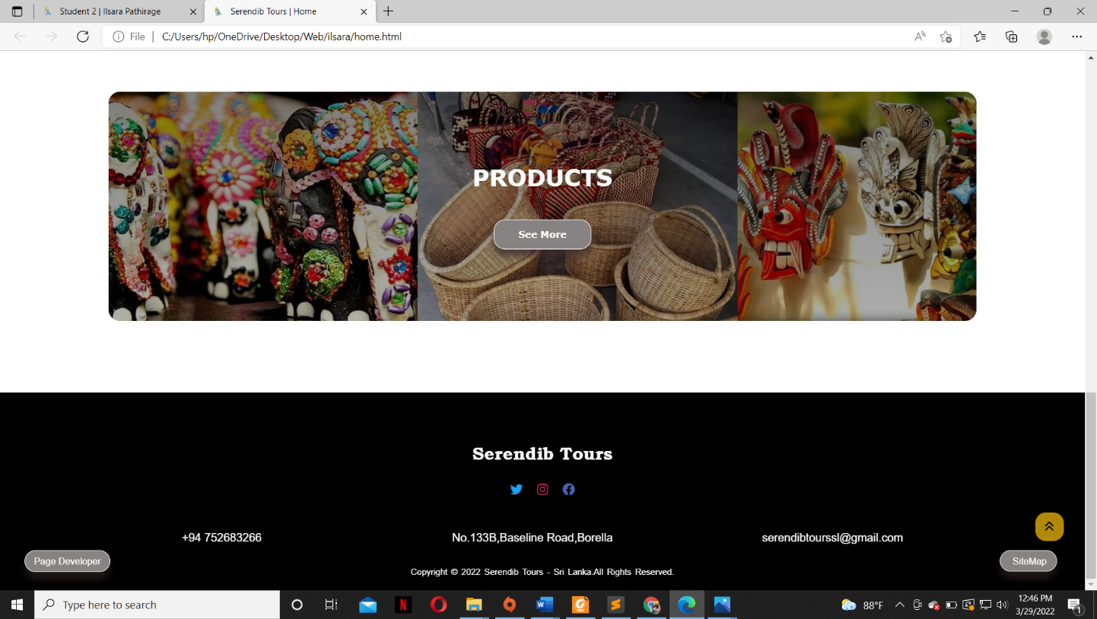

Bottom of every page has footer consist with our name, phone number, local address, email address. And also, there are social media to contact us, watch what we have done earlier and update user. ‘Page Developer’ is linked left corner of the footer, along with right corner button linked to the ‘Sitemap’. This page consists a back to top button for user’s efficiency. This button will appear only if user scroll down 700 pixels from top of the webpage. This bottom to top button also has hover effect.

**HTML:**

<i class="fa-solid fa-angles-up" onclick="topFunction()" title="Go to top"></i>

**JavaScript:**

myicon = document.getElementById("up_btn");

// Scrolls down 700px, show the button

window.onscroll = function() {scrollFunction()};

function scrollFunction() {

if (document.body.scrollTop > 700 || document.documentElement.scrollTop > 700) {

myicon.style.display = "block";

} else {

myicon.style.display = "none";

}

}

function topFunction() {

document.body.scrollTop = 0;

document.documentElement.scrollTop = 0;

}

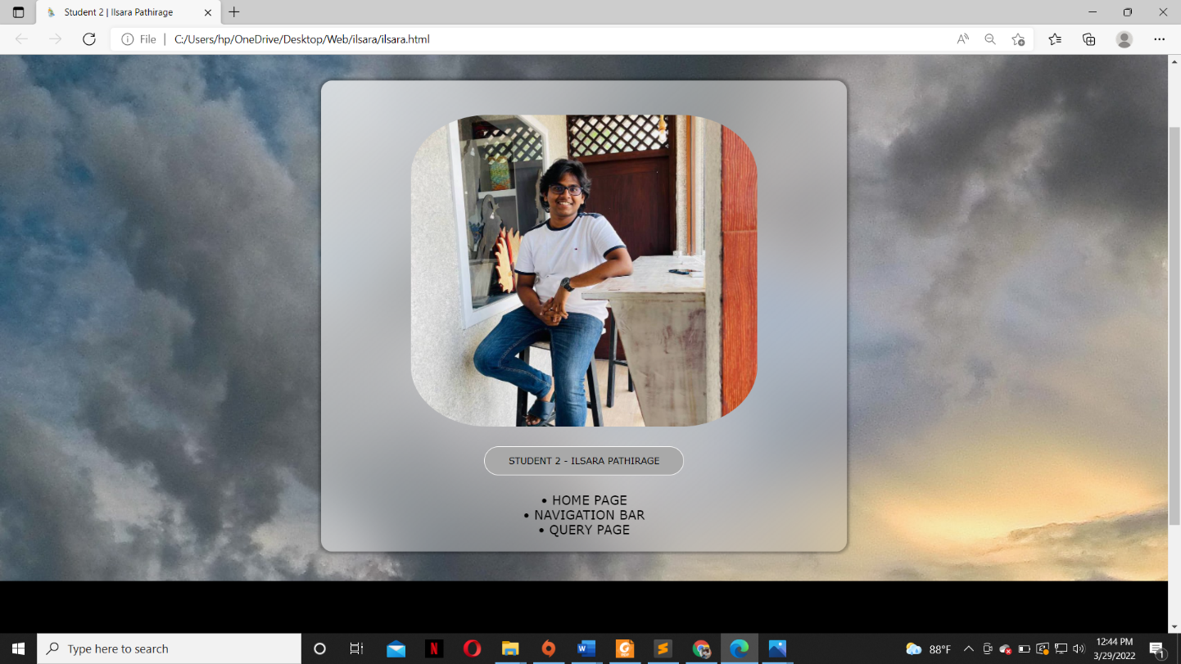**2.5 Page Editor page**

This page includes the name of the developer, image and tasks completed. For each individual developer has a separate page.

**2.6 Tours Page (Extra content page)**

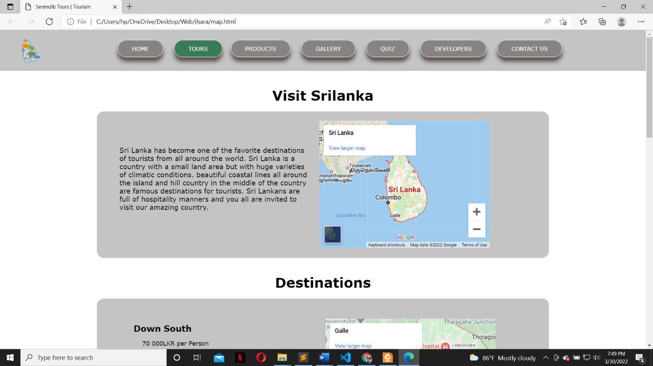

Top of the page includes small description about Sri Lankan tourism and google of the Sri Lanka.

<iframe src="https://www.google.com/maps/embed?pb=!1m18!1m12!1m3!1d4047271.2902942714!2d78.46188228553409!3d7.8517325074609206!2m3!1f0!2f0!3f0!3m2!1i1024!2i768!4f13.1!3m3!1m2!1s0x3ae2593cf65a1e9d%3A0xe13da4b400e2d38c!2sSri%20Lanka!5e0!3m2!1sen!2slk!4v1648579332327!5m2!1sen!2slk" width="400" height="300" style="border:0;" allowfullscreen="" loading="lazy" referrerpolicy="no-referrer-when-downgrade">

</iframe>

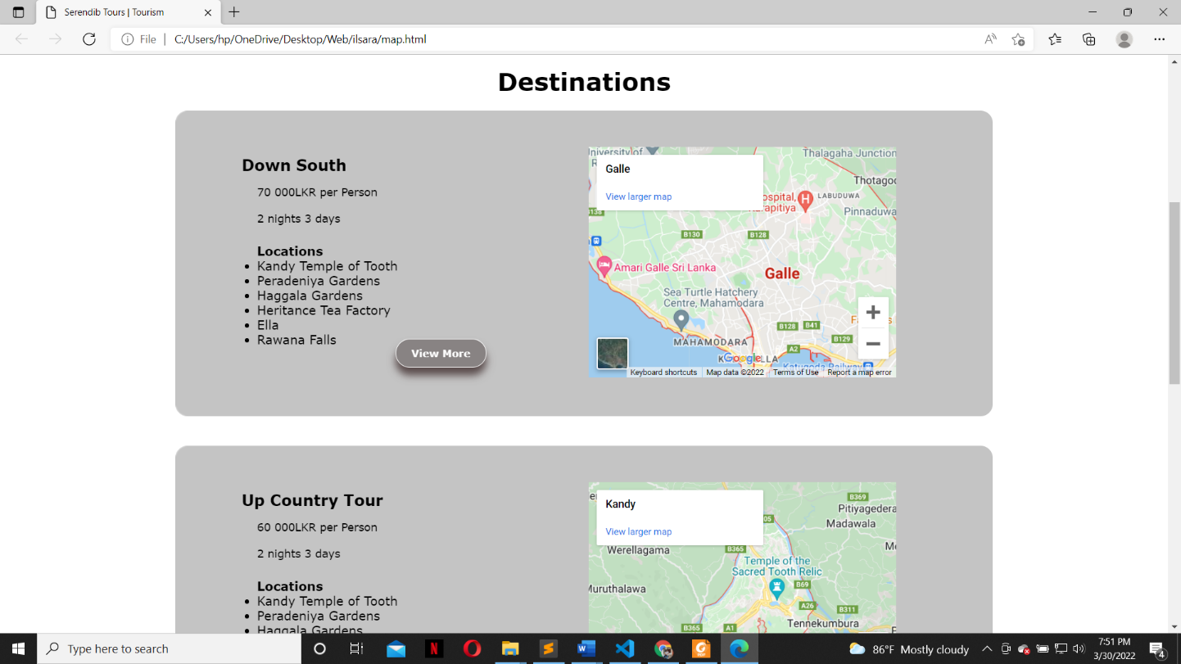

After that there are three tours we offer to our users and web page has given brief introduction to the tours and there is button called ‘View more’. The three tours we offer are Down south tour. Up country tour and Jaffna tour. If user clicks on that button he/she will redirect to the relevant webpage that we have created.

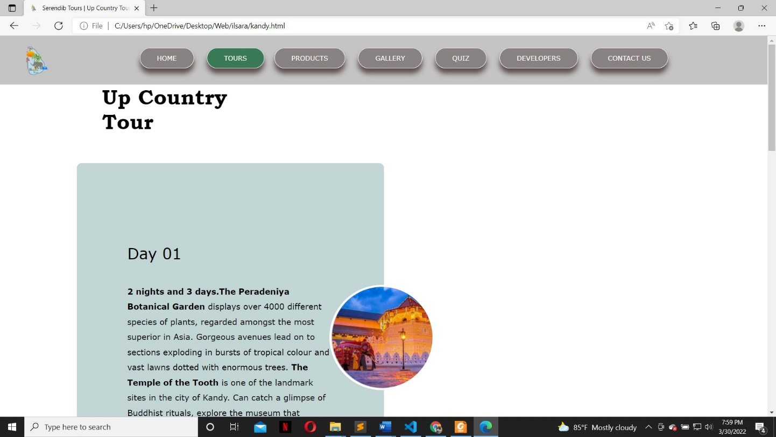

# Webpage Validation Statement

**Home page** - Validated without errors

**Query page** - Validated without errors

**Page Editor page -** Validated without errors

# Janet

Janet is a high-speed network for the UK research and education community provided by JISC (Joint Information Systems Committee), which is used to manage the process and development of the UK's national education and research network.

* Does not allow any content of libellous nature
* Does not provide the platform for unsolicited advertising in any form or any other similar activities.
* Does to not create or share any content that consists of a threatening nature or materials that maybe used to harass or harm an individual
* All pictures used are not copyrighted and creditors are given and referred when required
* Does to not create or share any offensive or obscene material
* Does not hack or breach the user data or perform any illegal disruptive activity

This website was developed for the working website for a coursework specification under University of Westminster. This website is not for profit or any financial benefit. This website complies with all of JANET's security requirements. As a result of these factors, this website confirms that it complies with all JANET policies and legal requirements. In some cases, organizations may be held legally liable for the actions of their members.

# 

# 

# References

* + JISC – Jisc Community (2022), Security Policy [online], Available from: <https://community.jisc.ac.uk/library/janet-services-documentation/janet-policies-and-legal-requirements> [Accessed 29 March 2022]
  + W3schools.com. (2022), Slideshow, Available from: <https://www.w3schools.com/howto/howto_js_slideshow.asp> [Accessed 25 March 2022]
  + W3schools.com. (2022), Image Hover Overlay Available from: <https://www.w3schools.com/howto/howto_css_image_overlay.asp> [Accessed 26 March 2022]
  + W3schools.com. (2022), Scroll back to Top button. Available from: <https://www.w3schools.com/howto/howto_js_scroll_to_top.asp>

[Accessed 28 March 2022]

* + W3schools.com. (2022), CSS/JS Modal, Available from: <https://www.w3schools.com/howto/howto_css_modals.asp>

[Accessed 28 March 2022]

* + W3schools.com. (2022), JavaScript Forms, Available from: <https://www.w3schools.com/js/js_validation.asp>

[Accessed 27 March 2022]

* + Stack overflow. (2022), [What's the best way to validate an email address in JavaScript?](https://stackoverflow.com/questions/46155/whats-the-best-way-to-validate-an-email-address-in-javascript), Available from: <https://stackoverflow.com/questions/46155/whats-the-best-way-to-validate-an-email-address-in-javascript> [Accessed 27 March 2022]

# 6. Appendices

## 6.1 Appendix A: Code

* **Home.html**

<!DOCTYPE html>

<html lang="en">

<head>

<meta charset="utf-8">

<meta name="viewport" content="width=device-width, initial-scale=1">

<title>Serendib Tours | Home</title>

<link rel="icon" href="./images/logo.png" type="image/icontype">

<script src=<https://kit.fontawesome.com/08fd8f9fea.js> crossorigin="anonymous"></script>

<!-- CSS -->

<link rel="stylesheet" href="./css/Navigation.css">

<link rel="stylesheet" href="./css/home.css">

<link rel="stylesheet" href="./css/footer.css">

</head>

<body>

<!-- bottom to Top -->

<div class="arrow_up" id="up_btn">

<i class="fa-solid fa-angles-up" onclick="topFunction()" title="Go to top"></i>

</div>

<!-- Navigation Bar -->

<section class="Navigation_Bar">

<nav class="links">

<a href="Home.html"><img class="logo" src="./images/logo.png" alt="logo" ></a>

<div class="Navigation_links" id="navLinks">

<ul>

<li><a href="Home.html" class="active">HOME</a></li>

<li><a href="map.html ">TOURS</a>

<li><a href="products.html">PRODUCTS</a></li>

<li><a href="gallery.html">GALLERY</a></li>

<li><a href="start.html">QUIZ</a></li>

<li><a href="studentdetail.html">DEVELOPERS</a></li>

<li><a href="query.html">CONTACT US</a></li>

</ul>

</div>

</nav>

</section>

<!-- SlideShow -->

<div class="slideshow_container">

<!-- Nine Arch Bridge -->

<div class="Slides fade">

<div class="num">1 / 6</div>

<img src="./images/train.jpg" alt="Nine Arch Bridge" class="slides">

<div class="overlay">

<div class="slidetext">

<h1 class="topic">SERENDIB TOURS</h1><br><br><h2>Nine Arch Bridge</h2><p><br><br>The Nine Arch Bridge, also known as the ‘Bridge in the Sky’ was constructed by connecting two bog mountains when constructing the Badulla – Colombo railway. This bridge is 300 feet in length, 25 feet in width and 80-100 feet in height. It is one of the best examples of colonial-era railway construction in the country. The Bridge can be reached by travelling 2km on Gotuwala road starting from Halpe Textile centre in Badulla Bandarawela road. The surrounding area has seen a steady increase in tourism due to the bridge’s architectural ingenuity and the profuse greenery in the nearby hillsides.</p>

</div>

/div>

</div>

<!-- Sigiriya -->

<div class="Slides fade">

<div class="num">2 / 6</div>

<img src="./images/sigiriya.jpg" alt="sigiriya" class="slides">

<div class="overlay">

<div class="slidetext">

<h1 class="topic">SERENDIB TOURS</h1><br><br><h2>Nine Arch Bridge</h2><p><br><br>Sigiriya is also called Lion Rock site in central Sri Lanka consisting of the ruins of an ancient stronghold that was built in the late 5th century CE on a remarkable monolithic rock pillar. The Sinhalese king Kashyapa I (reigned 477–495) built a palace in the shape of a monumental lion on the several acres of ground at the summit, intending it to be a safeguard against his enemies. There are 21 rock paintings of apsaras (celestial singers and dancers). Sigiriya was designated a UNESCO World Heritage site in 1982.</p>

</div>

</div>

</div>

<!-- Temple Of Tooth Relic -->

<div class="Slides fade">

<div class="num">3 / 6</div>

<img src="./images/templeOfTooth.jpg" alt="TempleOfToothRelic" class="slides">

<div class="overlay">

<div class="slidetext">

<h1 class="topic">SERENDIB TOURS</h1><br><br><h2>Temple Of Tooth Relic - Kandy</h2><p><br><br>Temple of the Sacred Tooth Relic commonly known as the Sri Dalada Maligawa It is located in the royal palace complex of the former Kingdom of Kandy, which houses the relic of the tooth of the Buddha. Since ancient times, the relic has played an important role in local politics because it is believed that whoever holds the relic holds the governance of the country. The relic was historically held by Sinhalese kings. The temple of the

tooth is a World Heritage Site mainly due to the temple and the relic.</p>

</div>

</div>

</div>

<!-- Yala National Park -->

<div class="Slides fade">

<div class="num">4 / 6</div>

<img src="./images/yala.jpg" alt="Yala National Park" class="slides">

<div class="overlay">

<div class="slidetext">

<h1 class="topic">SERENDIB TOURS</h1><br><br><h2>Yala National Park</h2><p><br><br>Yala combines a strict nature reserve with a national park.Divided into 5 blocks.Among its more famous residents are the world’s biggest concentration of leopards, majestic elephants, sloth bears, sambars, jackals, spotted dear, peacocks, and crocodiles. The best time to visit Yala is between February and July when the water levels of the park are quite low, bringing animals into the open. </p>

</div>

</div>

</div>

<!-- Whales and Dolphin watching -->

<div class="Slides fade">

<div class="num">5 / 6</div>

<img src="./images/dolphin.jpg" alt="Whales and Dolphin watching" class="slides">

<div class="overlay">

<div class="slidetext">

<h1 class="topic">SERENDIB TOURS</h1><br><br><h2>Whales and Dolphin watching</h2><p><br><br>Whales and dolphin watching in Mirissa in one of the most existing activity. Mirissa is the best place to start your whale and dolphin watching tour in Sri Lanka. World’s best: As per the research, the deep south of Sri Lanka (off Mirissa) is one of the world's best locations (amongst the top two or three) for watching Blue Whales and Sperm Whales, two of the most sought-after marine mammals. In fact, for seeing both Sperm and Blue Whales together, it may even turn out to be the best location in the world. The waters off Mirissa in the southern coast of Sri Lanka are home to some of the largest whale and dolphin colonies in the world.</p>

</div>

</div>

</div>

<!-- Coral Sanctuary - Hikkaduwa -->

<div class="Slides fade">

<div class="num">6 / 6</div>

<img src="./images/hikkaduwa.jpg" alt="Coral Sanctuary - Hikkaduwa" class="slides">

<div class="overlay">

<div class="slidetext">

<h1 class="topic">SERENDIB TOURS</h1><br><br><h2>Coral Sanctuary - Hikkaduwa</h2><p><br><br>Hikkaduwa coral reef is a typical shallow fringing reef with an average depth of around 5 metres (16 ft). The coral reef reduces the coastal erosion and forms a natural breakwater Staghorn, elkhorn, cabbage, brain, table and star corals are all present in the reef. Corals of 60 species belonging to 31 genera are recorded from the reef. The reef also recorded over 170 species of reef fish belonging to 76 genera. Seagrasses provide habitat to dugongs and sea turtles. Some species of prawns feed on the seagrass. Eight species of ornamental fishes also inhabit the reef, along with many vertebrates and invertebrates including crabs, prawns, shrimps, oysters and sea worms. Porites desilveri is an endemic coral species of Sri Lanka.</p>

</div>

</div>

</div>

</div><br>

<div style="text-align:center">

<span class="bullets"></span>

<span class="bullets"></span>

<span class="bullets"></span>

<span class="bullets"></span>

<span class="bullets"></span>

<span class="bullets"></span>

</div><br><br><br>

<!-- Web page description -->

<div class="row">

<div class="column_1">

<h1 class="topic">SERENDIB TOURS</h1>

<h2>Creating and facilitating truly memorable travel experiences in the paradise isle.</h2><p>Welcome to the website of Sri Lanka's number one Destination Management Company, which provides a wonderful travel experience with access to the best hotels, tourist attractions, and activities in the country. Serendib Tours welcomes all types of travellers to a haven of leisure and relaxation, offering a full range of travel tours and unique encounters cantered on a tropical culture and colorful history that attempts to transport you back in time.</p>

<a href="map.html" class="button">See More</a>

</div>

<!-- Web page logo -->

<div class="column_2">

<img src="./images/logo.png" alt="logo" width="250" height="250">

</div>

</div>

<!-- Products -->

<div class="products">

<h1>PRODUCTS</h1>

<a href="products.html" class="button">See More</a>

</div>

<!-- Footer -->

<footer>

<button class="sitemap_btn" onclick="location.href='sitemap.html'">SiteMap</button>

<button class="developer_btn" onclick="location.href='ilsara.html'">Page Developer</button>

<div class="footer_content">

<h3> Serendib Tours</h3>

<ul class="socials">

<li> <a href="https://twitter.com/SerendibTours2"><i class="fa-brands fa-twitter" style="color:#1DA1F2"></i></a></li>

<li> <a href="https://www.instagram.com/serendib_tours"><i class="fa-brands fa-instagram" style="color:#E1306C"></i></a></li><li>

<a href="https://www.facebook.com/profile.php?id=100079049926088"><i class="fa-brands fa-facebook" style="color:#4267B2"></i></a></li>

</ul>

<ul class="details">

<li class="number">+94 752683266 </li>

<li class="address">&nbsp;&nbsp;&nbsp;&nbsp;&nbsp;&nbsp;&nbsp;&nbsp;&nbsp;&nbsp;&nbsp;&nbsp;&nbsp;&nbsp; No.133B,Baseline Road,Borella &nbsp; </li>

<li class="mail"> serendibtourssl@gmail.com </li>

</ul>

</div>

<div class="footer-bottom">

<p>Copyright &copy; 2022 Serendib Tours - Sri Lanka.All Rights Reserved.</p>

</div>

</footer>

<!-- Java Script -->

<script src="./js/home.js"></script>

</body>

</html>

* **home.css**

/* Home Page */

html {

scroll-behavior: smooth;

}

/* Slideshow container */

.slideshow_container {

display: flew;

width: 100%;

overflow: hidden;

object-fit: cover;

}

/* Number text (1/7) */

.num{

color: white;

font-size: 12px;

padding: 8px 12px;

position: absolute;

}

/* bullets */

.bullets {

background-color: white;

display: inline-block;

}

/* Fading animation */

.fade {

-webkit-animation-name: fade;

-webkit-animation-duration: 1.5s;

animation-name: fade;

animation-duration: 1.5s;

}

@-webkit-keyframes fade {

from {opacity: .4}

to {opacity: 1}

}

@keyframes fade {

from {opacity: .4}

to {opacity: 1}

}

/* On smaller screens, decrease text size */

@media only screen and (max-width: 300px) {

.text {font-size: 11px}

}

/* slides hover */

.slideshow_container {

position: relative;

width: 100%;

}

.slides {

display: block;

width: 100%;

height: auto;

max-height: 650px;

}

/* slides over transition*/

.overlay {

position: absolute;

top: 0;

bottom: 0;

left: 0;

right: 0;

height: 100%;

width: 100%;

opacity: 0;

transition: .7s ease;

background-color: rgba(0,0,0,0.4);

}

.slideshow_container:hover .overlay {

opacity: 1;

}

/* slides over words */

.slidetext {

color: white;

position: relative;

padding: 0 130px;

text-align: center;

top: 50%;

left: 50%;

-webkit-transform: translate(-50%, -50%);

-ms-transform: translate(-50%, -50%);

transform: translate(-50%, -50%);

}

.topic{

font-family: Bookman Old Style;

}

/*Srendib Tours Description*/

.row {

display: flex;

width: 90%;

margin: auto;

background: #C4C4C4;

border-radius: 1rem;

overflow: hidden;

}

.column_1, .column_2 {

overflow: hidden;

backdrop-filter: blur(1px);

}

.column_1 {

padding: 2% 3% 2%;

}

.column_1 h1 {

font-size: 50px;

color: black;

}

.column_1 h2 {

color: black;

line-height: 1.6;

margin: 15px 0 30px;

}

.column_1 p {

color: black;

line-height: 1.6;

margin: 15px 0 30px;

font-size: 18px;

}

.column_2{

width: 100%;

position: relative;

top: 75px;

right: 20px;

padding: 2% 2% 2%;

}

/*Srendib Tours Description Button*/

.button {

display: inline-block;

text-decoration: none;

color: white;

border: 1px solid #fff;

padding: 12px 34px;

font-size: 13px;

font-weight: bold;

background-color: #888383;

position: relative;

cursor: pointer;

transition: 1s;

border-radius: 50px;

box-shadow: 0 10px 10px rgba(65, 47, 47, 0.8);

}

/*Srendib Tours Description Button hover*/

.button:hover {

border: 1px solid #ffffff;

background: #404040;

color: white;

}

/* products */

.products {

margin: 100px auto;

width: 80%;

position: relative;

background-image: linear-gradient(rgba(0,0,0,0.5), rgba(0,0,0,0.3)), url(../images/products.jpg);

background-position: center;

background-size: cover;

border-radius: 1rem;

text-align: center;

padding: 100px 0;

}

.products h1 {

color: #fff;

margin-bottom: 40px;

padding: 0;

}

* **Navigation.css**

* {box-sizing: border-box;

margin: 0;

padding: 0;

}

body {font-family: Verdana, sans-serif;}

/* Navigation Bar logo */

.logo{

width: 80px;

height: 70px;

position: relative;

left: 30px;

bottom: 9px;

}

/* Navigation Bar */

.Navigation_Bar {

width: 100%;

position: relative;

}

/* Navigation button links */

.links {

display: flex;

padding-top: 1.5%; /* space between nav button, top & slides*/

background-color: #C4C4C4;

}

.Navigation_links {

flex: 1;

text-align: center;

}

.Navigation_links ul li {

display: inline-block;

padding: 10px 10px 10px 10px;

position: relative;

}

/* active page changes */

.Navigation_links .active {

border: 1px solid white;

color: white;

background-color: #3b7a57;

}

/*Navigation button attributes*/

.Navigation_links ul li a {

color: #fff;

font-size: 13px;

text-decoration: none;

cursor: pointer;

color: rgb(255, 255, 255);

border: 1px solid white;

padding: 12px 33px;

background: #888383;

position: relative;

transition: 1s;

border-radius: 50px;

box-shadow: 0 10px 10px rgba(65, 47, 47, 0.8);

}

/* Navigation Button hover */

.Navigation_links ul li a:hover {

border: 1px solid #ffffff;

background: #404040;

color: white;

}

/* Back To Top */

.arrow_up{

height: 40px;

width:40px;

text-align: center;

background: #ffc40c;

cursor: pointer;

position: fixed;

bottom: 70px;

right: 30px;

z-index: 99;

border: none;

outline: none;

line-height: 39px;

color:black;

border-radius: 15px;

background-color: rgba(255,196,12,0.7);

}

.arrow_up:hover {

background-color: rgb(255,196,12);

}

* **footer.css**

*{

margin:0;

padding:0;

box-sizing: border-box;

}

body{

background: white ;

}

footer{

background: black;

height:auto;

width:100%;

font-family: 'Poppins', sans-serif;

padding-top: 40px;

color: white;

}

h3{

font-family: bookman old style;

}

.sitemap_btn{

border-radius: 20px;

width:80px;

height:30px;

position: relative;

left:1400px;

top:180px;

display: inline-block;

text-decoration: none;

color: white;

border: 1px solid #fff;

padding: 7px 17px;

font-size: 13px;

background-color: #888383;

position: relative;

cursor: pointer;

transition: 1s;

border-radius: 1rem;

box-shadow: 0 10px 10px rgba(65, 47, 47, 0.5);

}

.sitemap_btn:hover {

border: 1px solid #ffffff;

background: #404040;

color: white;

}

.developer_btn{

border-radius: 20px;

width:120px;

height:30px;

position: relative;

left:-50px;

top:180px;

display: inline-block;

text-decoration: none;

color: white;

border: 1px solid #fff;

padding: 6px 10px;

font-size: 13px;

background-color: #888383;

position: relative;

cursor: pointer;

transition: 1s;

border-radius: 1rem;

box-shadow: 0 10px 10px rgba(65, 47, 47, 0.5);

}

.developer_btn:hover {

border: 1px solid #ffffff;

background: #404040;

color: white;

}

.footer_content{

display:flex;

align-items: center;

justify-content: center;

flex-direction: column;

text-align: center;

}

.footer_content h3{

padding-bottom: 40px;

height: 12px;

font-size: 25px;

}

.socials{

list-style-type: none;

display: flex;

align-items: center;

justify-content: center;

margin: 1rem 0 3rem 0;

}

.socials li{

margin: 0 10px;

}

.socials a{

text-decoration: none;

color: white;

}

.socials a i{

font-size: 1.1rem;

transition: color .4s ease;

}

.socials a:hover i{

color: aqua;

}

.details{

display:flex;

list-style-type:none;

column-gap: 200px;

height:30px;

align-content: center;

}

.address{

text-align: center;

}

.footer-bottom{

background: black;

width:100%;

padding:20px;

text-align: center;

}

.footer-bottom p{

font-size: 12px;

word-spacing: 2px;

}

* **Home.js**

/* Slideshow */

var slideIndex = 0;

showSlides();

function showSlides() {

var i;

var slides = document.getElementsByClassName("Slides");

var dots = document.getElementsByClassName("bullets");

for (i = 0; i < slides.length; i++) {

slides[i].style.display = "none";

}

slideIndex++;

if (slideIndex > slides.length) {slideIndex = 1}

for (i = 0; i < dots.length; i++) {

dots[i].className = dots[i].className.replace(" active", "");

}

slides[slideIndex-1].style.display = "block";

dots[slideIndex-1].className += " active";

setTimeout(showSlides, 4000); // Change image every 4 seconds

}

/* Bottom to top button */

myicon = document.getElementById("up_btn");

// Scrolls down 700px, show the button

window.onscroll = function() {scrollFunction()};

function scrollFunction() {

if (document.body.scrollTop > 700 || document.documentElement.scrollTop > 700) { //button shows when pages down 600px

myicon.style.display = "block";

} else {

myicon.style.display = "none";

}

}

function topFunction() {

document.body.scrollTop = 0; // For Safari

document.documentElement.scrollTop = 0; // For Chrome, Firefox, IE and Opera

}

* **query.html**

<!DOCTYPE html>

<html>

<head>

<meta charset="utf-8">

<meta name="viewport" content="width=device-width, initial-scale=1">

<title>Serendib Tours | Contact Us</title>

<link rel="icon" href="./images/logo.png" type="image/icontype">

<script src=<https://kit.fontawesome.com/08fd8f9fea.js> crossorigin="anonymous"></script>

<!-- CSS -->

<link rel="stylesheet" href="./css/Navigation.css">

<link rel="stylesheet" href="./css/query.css">

<link rel="stylesheet" href="./css/footer.css">

</head>

<body>

<!-- Navigation Bar -->

<section class="Navigation_Bar">

<nav class="links">

<a href="Home.html"><img class="logo" src="./images/logo.png" alt="logo" ></a>

<div class="Navigation_links" id="navLinks">

<ul>

<li><a href="Home.html" >HOME</a></li>

<li><a href="map.html ">TOURS</a>

<li><a href="products.html">PRODUCTS</a></li>

<li><a href="gallery.html">GALLERY</a></li>

<li><a href="start.html">QUIZ</a></li>

<li><a href="studentdetail.html">DEVELOPERS</a></li>

<li><a href="query.html" class="active">CONTACT US</a></li>

</ul>

</div>

</nav>

</section>

<!-- Query Form -->

<div class="query_back">

<div class="contact_us">

<form name="form" action="mailto:serendibtourssl@gmail.com" method="post" enctype="text/plain">

<div class="query_title">

QUERY FORM

</div>

<div class="query_form">

<div class="query_input">

<label for="fname">First Name</label>

<input type="text" class="form_input" name = "First name" id="fname">

</div>

<div class="query_input">

<label for="lname">Last Name</label>

<input type="text" class="form_input" name = "Last name" id="lname">

</div>

<div class="query_input">

<label for="email">Email Address</label>

<input type="text" class="form_input" name = "E mail" id="email">

</div>

<div class="query_input">

<label for="subject">Subject</label>

<div class="subject_select">

<select name = "Subject" id="subject">

<option value="">Select</option>

<option value="delivery">Delivery</option>

<option value="booking">Booking</option>

<option value="locations">Locations</option>

<option value="Other">Other</option>

</select>

</div>

</div>

<div class="query_input">

<label for="details">Details</label>

<textarea class="form_textarea" name = "Details" id="details"></textarea>

</div>

<div class="query_input">

<button onclick="validateForm();" class="view_button" type="button" id="view" >View Query</button>

<button class="reset_button" type="reset" id="reset" >Reset</button>

</div>

</div>

</div>

<div id="getdetail" class="detail_box">

<!-- Detail content -->

<div class="detail-content">

<h2 style="font-weight: bold; font-family:bookman old style;" > SERENDIB TOURS </h2><br>

<h3 style="font-weight: bold;"> DETAILS </h3>

<br><br>

<p id="deta"></p>

<br><br><br>

<button type="button" value="edit" class="edit">Edit</button>

<button type="submit" value="Send" class="sub" >Send</button>

</div>

</div>

<br><br><br>

</form>

<!-- Footer -->

<footer>

<button class="sitemap_btn" onclick="location.href='sitemap.html'">SiteMap</button>

<button class="developer_btn" onclick="location.href='ilsara.html'">Page Developer</button>

<div class="footer_content">

<h3> Serendib Tours</h3>

<ul class="socials">

<li> <a href="https://twitter.com/SerendibTours2"><i class="fa-brands fa-twitter" style="color:#1DA1F2"></i></a></li>

<li> <a href="https://www.instagram.com/serendib_tours"><i class="fa-brands fa-instagram" style="color:#E1306C"></i></a></li><li>

<a href="https://www.facebook.com/profile.php?id=100079049926088"><i class="fa-brands fa-facebook" style="color:#4267B2"></i></a></li>

</ul>

<ul class="details">

<li class="number">+94 752683266 </li>

<li class="address">&nbsp;&nbsp;&nbsp;&nbsp;&nbsp;&nbsp;&nbsp;&nbsp;&nbsp;&nbsp;&nbsp;&nbsp;&nbsp;&nbsp; No.133B,Baseline Road,Borella &nbsp; </li>

<li class="mail"> serendibtourssl@gmail.com </li>

</ul>

</div>

<div class="footer-bottom">

<p>Copyright &copy; 2022 Serendib Tours - Sri Lanka.All Rights Reserved.</p>

</div>

</footer>

<!-- Java Script -->

<script src="./js/query.js"></script>

</div>

</body>

</html>

* **query.css**

/* Background img */

.query_back{

height: 100%;

width: 100%;

position: absolute;

background: fixed;

background: url(../images/q_back.jpg);

}

/* query form box */

.contact_us {

margin: 50px auto;

overflow: hidden;

max-width: 700px;

background-position: center;

background-repeat: no-repeat;

width: 100%;

background: linear-gradient(to right bottom, rgba(255, 255, 255, 0.5), rgba(255, 255, 255, 0.8));

padding: 20px 50px;

border-radius: 1rem;

box-shadow: 3px 3px 5px rgba(0,0,0,0.5);

backdrop-filter: blur(5px);

position: relative;

top: 27px;

}

.contact_us .query_title {

font-size: 24px;

font-weight: 600;

margin-bottom: 25px;

color: black;

text-transform: uppercase;

}

.contact_us .query_form {

width: 100%;

}

/* query form inputs */

.contact_us .query_form .query_input {

margin-bottom: 15px;

display: flex;

align-items: center;

}

.contact_us .query_form .query_input label {

width: 200px;

color: black;

margin-right: 10px;

font-size: 14px;

}

.contact_us .query_form .query_input .form_input,

.contact_us .query_form .query_input .form_textarea {

width: 100%;

outline: none;

border: 1px solid rgb(102, 102, 102);

font-size: 15px;

padding: 8px 10px;

border-radius: 5px;

transition: all 1s ease;

background: rgba(255,255,255,0.2);

color: black;

}

.contact_us .query_form .query_input .form_textarea {

resize: none;

height: 100px;

font-size: 15px;

}

.contact_us .query_form .query_input .subject_select {

position: relative;

width: 100%;

height: 40px;

}

.contact_us .query_form .query_input .subject_select select {

appearance: none;

color: rgb(0, 0, 0);

border: 1px solid rgb(102, 102, 102);

background: rgba(255,255,255,0.2);

padding: 10px 5px;

height: 100%;

width: 100%;

outline: none;

border-radius: 5px;

}

.contact_us .query_form .query_input .subject_select::before {

content: "";

position: absolute;

top: 16px;

right: 10px;

border: 8px solid;

border-color: rgb(161, 161, 161) transparent transparent transparent;

pointer-events: none;

}

.contact_us .query_form .query_input input:focus,

.contact_us .query_form .query_input .form_textarea:focus,

.contact_us .query_form .query_input select:focus {

border: 1px solid #a48f19;

box-shadow: 10px 0px 10px rgba(85, 60, 47, 0.7);

}

/* View Query Button */

.contact_us .query_form .query_input .view_button {

width: 2opx;

padding: 8px 10px;

font-size: 12px;

font-weight: 600;

border: 1px solid #fff;

text-decoration: none;

color: rgb(255, 255, 255);

padding: 12px 34px;

font-size: 13px;

background-color: #888383;

cursor: pointer;

transition: 1s;

border-radius: 50px;

position: relative;

left: 460px;

top: 5px;

box-shadow: 0 10px 10px rgba(65, 47, 47, 0.5);

}

.contact_us .query_form .query_input .view_button:hover {

border: 1px solid #ffffff;

background: #404040;

color: white;

}

/* Reset Button */

.contact_us .query_form .query_input .reset_button {

width: 2opx;

padding: 8px 10px;

font-size: 12px;

font-weight: 600;

border: 1px solid #fff;

text-decoration: none;

color: rgb(255, 255, 255);

padding: 12px 34px;

font-size: 13px;

background-color: #888383;

cursor: pointer;

transition: 1s;

border-radius: 50px;

position: relative;

left: 200px;

top: 5px;

box-shadow: 0 10px 10px rgba(65, 47, 47, 0.5);

}

.contact_us .query_form .query_input .reset_button:hover {

border: 1px solid #ffffff;

background: #404040;

color: white;

}

.detail_box {

display: none;

position: fixed;

z-index: 1;

padding-top: 100px;

left: 0;

top: 0;

width: 100%;

height: 100%;

overflow: auto;

background-color: rgb(0,0,0);

background-color: rgba(0,0,0,0.4);

}

/* Detail content */

.detail-content {

background: #C4C4C4;

border-radius: 1rem;

box-shadow: 3px 3px 5px rgba(0,0,0,0.5);

margin: auto;

padding: 40px;

border: 1px solid #888;

width: 50%;

height: 90%;

}

/* edit Button */

.edit {

display: inline-block;

text-decoration: none;

color: white;

border: 1px solid #fff;

padding: 12px 34px;

font-size: 13px;

font-weight: bold;

background-color: #888383;

position: relative;

top: 20px;

left: 460px;

cursor: pointer;

transition: 1s;

border-radius: 50px;

box-shadow: 0 10px 10px rgba(65, 47, 47, 0.5);

}

.edit:hover {

border: 1px solid #ffffff;

background: #404040;

color: white;

}

/* Submit Button */

.sub {

display: inline-block;

text-decoration: none;

color: white;

border: 1px solid #fff;

padding: 12px 34px;

font-size: 13px;

font-weight: bold;

background-color: #888383;

position: relative;

top: 20px;

left: 480px;

cursor: pointer;

transition: 1s;

border-radius: 50px;

box-shadow: 0 10px 10px rgba(65, 47, 47, 0.5);

}

.sub:hover {

border: 1px solid #ffffff;

background: #404040;

color: white;

}

* **query.js**

function validateForm() {

var fname = document.getElementById("fname").value;

var lname = document.getElementById("lname").value;

var email = document.getElementById("email").value;

var details = document.getElementById("details").value;

var subject = document.getElementById("subject").value;

var emailRangeCheck = /^(([^<>()[\][\\.,;:\s@"]+(\.[^<>()[\]\\.,;:\s@"]+)*)|(".+"))@((\[[0-9]{1,3}\.[0-](file:///\\.,;:\s@%22%5d+(\.%5b%5e%3c%3e()%5b\%5d\\.,;:\s@%22%5d+)*)|(%22.+%22))@((\%5b%5b0-9%5d%7b1,3%7d\.%5b0-) 9]{1,3}\.[0-9]{1,3}\.[0-9]{1,3}\])|(([a-zA-Z\-0-9]+\.)+[a-zA-Z]{2,}))$/

if (fname == "" ) {

alert ("Please enter your First Name");

return false;

}

if (lname == "" ) {

alert ("Please enter your Last Name");

return false;

}

if (email == "" ) {

alert ("Please enter your Email");

return false;

}

if(!emailRangeCheck.test(email)){

alert ("Please enter a valid Email");

return false;

}

if (subject == "") {

alert ("Please select a subject");

return false;

}

if(details == "" ) {

alert ("Please enter details");

return false;

}

var detail_box = document.getElementById("getdetail"); //Detail Box

var btn = document.getElementById("view"); // Get the button that opens the detail box

var span = document.getElementsByClassName("edit")[0]; // Get the <span> element that closes the detail box

//user clicks the view query button, open the detail box

btn.onclick = function() {

detail_box.style.display = "block";

}

//user clicks on <span> (edit), close the detail box

span.onclick = function() {

detail_box.style.display = "none";

}

//When the user clicks anywhere outside of the detail box, close it

window.onclick = function(event) {

if (event.target == detail_box) {

detail_box.style.display = "none";

}

}

document.getElementById("deta").innerHTML="First Name : "+fname+"<br><br>"+"Last Name : "+lname+"<br><br>"+"Email &nbsp;&nbsp;&nbsp;&nbsp;&nbsp;&nbsp;&nbsp;: "+email+"<br><br>"+"Subject &nbsp;&nbsp;&nbsp;&nbsp;: "+subject+"<br><br>"+"Details &nbsp;&nbsp;&nbsp;&nbsp;&nbsp;: "+details;

document.getElementById("view").click();

}

* **ilsara.html**

<!DOCTYPE HTML>

<html>

<head>

<meta charset="UTF-8">

<meta name="viewport" content="width=device-width, initial-scale=1">

<title>Student 2 | ILSARA PATHIRAGE</title>

<link rel="icon" href="./images/logo.png" type="image/icontype">

<script src=<https://kit.fontawesome.com/08fd8f9fea.js> crossorigin="anonymous"></script>

<!-- CSS -->

<link rel="stylesheet" type="text/css" href="css/students.css">

<link rel="stylesheet" type="text/css" href="css/Navigation.css">

<link rel="stylesheet" href="css/footer.css">

</head>

<body style="background-image: url(./images/back.jpg);">

<section class="Navigation_Bar">

<nav class="links">

<a href="home.html"><img class="logo" src="images/logo.png" alt="logo"></a>

<div class="Navigation_links" id="navLinks">

<ul style="text-align: right">

<li><a href="studentdetail.html" class="active">DEVELOPERS</a></li>

<li><a href="home.html">HOME</a></li>

</ul>

</div>

</nav>

</section>

<br> <br> <br>

<div class="quiz-box" id="student">

<img src="images/ilsara.jpg" class="stu_img" alt="ilsara"><br>

<p id="button">STUDENT 2 - ILSARA PATHIRAGE

<br>

<ul>

<li>&#8226; HOME PAGE</li>

<li>&#8226; NAVIGATION BAR</li>

<li>&#8226; QUERY PAGE</li>

</ul>

<br>

</div>

<br> <br>

<!-- Footer -->

<footer>

<button class="sitemap_btn" onclick="location.href='sitemap.html'">SiteMap</button>

<button class="developer_btn" onclick="location.href='ilsara.html'">Page Developer</button>

<div class="footer_content">

<h3> Serendib Tours</h3>

<ul class="socials">

<li> <a href="https://twitter.com/SerendibTours2"><i class="fa-brands fa-twitter" style="color:#1DA1F2"></i></a></li>

<li> <a href="https://www.instagram.com/serendib_tours"><i class="fa-brands fa-instagram" style="color:#E1306C"></i></a></li><li>

<a href="https://www.facebook.com/profile.php?id=100079049926088"><i class="fa-brands fa-facebook" style="color:#4267B2"></i></a></li>

</ul>

<ul class="details">

<li class="number">+94 752683266 </li>

<li class="address">&nbsp;&nbsp;&nbsp;&nbsp;&nbsp;&nbsp;&nbsp;&nbsp;&nbsp;&nbsp;&nbsp;&nbsp;&nbsp;&nbsp; No.133B,Baseline Road,Borella &nbsp; </li>

<li class="mail"> serendibtourssl@gmail.com </li>

</ul>

</div>

<div class="footer-bottom">

<p>Copyright &copy; 2022 Serendib Tours - Sri Lanka.All Rights Reserved.</p>

</div>

</footer>

</body>

</html>

* **students.css**

.quiz-box {

background: rgb(255, 255, 255);

background: linear-gradient(to right bottom, rgba(255, 255, 255, 0.7), rgba(255, 255, 255, 0.1));

backdrop-filter: blur(2rem);

width: 45%;

min-height: 100px;

box-shadow: 0 0 5px 3px rgba(0,0,0,0.3);

border-radius: 1rem;

margin-left: auto;

margin-right: auto;

padding-top: 25px;

}

.stu_img{

width:500px;

height:500px;

text-align: center;

margin-right: auto;

margin-left: auto;

border-radius: 7rem;

padding-top: 25px;

padding-bottom: 25px;

}

body {

background-size:cover;

position: relative;

width: 100%;

height: 100%;

background-attachment:fixed;

color:black;

font-size:18px;

font-family: Arial;

}

#button ,#myBtn{

display: inline-block;

text-decoration: none;

color: black;

border: 1px solid white;

padding: 12px 34px;

font-size: 13px;

background: grey;

position: relative;

cursor: pointer;

transition: 1s;

border-radius: 50px;

margin-bottom:25px; }

#button,#myBtn:hover {

background-color:darkgray;

}

#student,#student ul{

text-align: center;

list-style: none;

}

.logo{

width: 5%;

height:10%;

padding-right: 10px;

}

* **map.html**

<!DOCTYPE html>

<html lang="en">

<head>

<meta charset="UTF-8">

<meta http-equiv="X-UA-Compatible" content="IE=edge">

<meta name="viewport" content="width=, initial-scale=1.0">

<title> Serendib Tours | Tourism </title>

<link rel="stylesheet" href="css/map.css">

<link rel="stylesheet" type="text/css" href="css/Navigation.css">

<link rel="stylesheet" href="css/footer.css">

<script src="https://kit.fontawesome.com/08fd8f9fea.js" crossorigin="anonymous"></script>

</head>

<body>

<main>

<!-- Navigation Bar -->

<div class="Navigation_Bar">

<nav class="links">

<a href="Home.html"><img class="logo" src="./images/logo.png" alt="logo" ></a>

<div class="Navigation_links" id="navLinks">

<ul>

<li><a href="Home.html" >HOME</a></li>

<li><a href="map.html" class="active">TOURS</a>

<li><a href="products.html">PRODUCTS</a></li>

<li><a href="gallery.html">GALLERY</a></li>

<li><a href="start.html">QUIZ</a></li>

<li><a href="studentdetail.html">DEVELOPERS</a></li>

<li><a href="Query.html">CONTACT US</a></li>

</ul>

</div>

</nav>

</div>

<br><br>

<h1>Visit Srilanka</h1>

<br>

<div class="row">

<div class="srilanka">

<p style="padding-top: 50px;"> Sri Lanka has become one of the favorite destinations of tourists from all around the world. Sri Lanka is a country with a small land area but with huge varieties of climatic conditions. beautiful coastal lines all around the island and hill country in the middle of the country are famous destinations for tourists. Sri Lankans are full of hospitality manners and you all are invited to visit our amazing country.

</p>

</div>

<div class="column_2">

<iframe src="https://www.google.com/maps/embed?pb=!1m18!1m12!1m3!1d4047271.2902942714!2d78.46188228553409!3d7.8517325074609206!2m3!1f0!2f0!3f0!3m2!1i1024!2i768!4f13.1!3m3!1m2!1s0x3ae2593cf65a1e9d%3A0xe13da4b400e2d38c!2sSri%20Lanka!5e0!3m2!1sen!2slk!4v1648579332327!5m2!1sen!2slk" width="400" height="300" style="border:0;" allowfullscreen="" loading="lazy" referrerpolicy="no-referrer-when-downgrade">

</iframe>

</div>

</div>

<br><br>

<h1>Destinations</h1>

<br>

<div class="row">

<div class="column_1">

<h2>Down South</h2>

<p>70 000LKR per Person</p>

<p>2 nights 3 days</p>

<h4><b>Locations</b></h4>

<ul>

<li>Kandy Temple of Tooth</li>

<li>Peradeniya Gardens</li>

<li>Haggala Gardens</li>

<li>Heritance Tea Factory</li>

<li>Ella</li>

<li>Rawana Falls</li>

</ul>

<a href="south.html" class="south_btn">View More</a>

</div>

<div class="column_2">

<iframe src="https://www.google.com/maps/embed?pb=!1m18!1m12!1m3!1d31740.423711819076!2d80.1944874294963!3d6.055891269316436!2m3!1f0!2f0!3f0!3m2!1i1024!2i768!4f13.1!3m3!1m2!1s0x3ae173bb6932fce3%3A0x4a35b903f9c64c03!2sGalle!5e0!3m2!1sen!2slk!4v1648579133580!5m2!1sen!2slk" width="400" height="300" style="border:0;" allowfullscreen="" loading="lazy" referrerpolicy="no-referrer-when-downgrade">

</iframe>

</div>

</div>

<br><br>

<div class="row">

<div class="column_1">

<h2>Up Country Tour</h2>

<p>60 000LKR per Person</p>

<p>2 nights 3 days</p>

<h4><b>Locations</b></h4>

<ul>

<li>Kandy Temple of Tooth</li>

<li>Peradeniya Gardens</li>

<li>Haggala Gardens</li>

<li>Heritance Tea Factory</li>

<li>Ella</li>

<li>Rawana Falls</li>

</ul>

<a href="kandy.html" class="kandy_btn">View More</a>

</div>

<div class="column_2">

<iframe src="https://www.google.com/maps/embed?pb=!1m18!1m12!1m3!1d63320.43003471!2d80.59076188946607!3d7.294543952151067!2m3!1f0!2f0!3f0!3m2!1i1024!2i768!4f13.1!3m3!1m2!1s0x3ae366266498acd3%3A0x411a3818a1e03c35!2sKandy!5e0!3m2!1sen!2slk!4v1648579186541!5m2!1sen!2slk" width="400" height="300" style="border:0;" allowfullscreen="" loading="lazy" referrerpolicy="no-referrer-when-downgrade">

</iframe>

</div>

</div>

<br><br>

<div class="row">

<div class="column_1">

<h2>Jaffna Tour</h2>

<p>55 000LKR per Person</p>

<p> 2 nights 3 days</p>

<h4><b>Locations</b></h4>

<ul>

<li>Nallur Kovil</li>

<li>Jaffna Public Library</li>

<li>Jaffna Fort</li>

<li>Nagadipa Temple</li>

<li>Dambakola Patuna</li>

<li>Nilaveli Beach</li>

</ul>

<a href="jaffna.html" class="jaffna_btn">View More</a>

</div>

<div class="column_2">

<iframe src="https://www.google.com/maps/embed?pb=!1m18!1m12!1m3!1d31465.03765674343!2d80.0109170808967!3d9.669957106979187!2m3!1f0!2f0!3f0!3m2!1i1024!2i768!4f13.1!3m3!1m2!1s0x3afe53fd7be66aa5%3A0xc7da0d9203baf512!2sJaffna!5e0!3m2!1sen!2slk!4v1648579228489!5m2!1sen!2slk" width="400" height="300" style="border:0;" allowfullscreen="" loading="lazy" referrerpolicy="no-referrer-when-downgrade">

</iframe>

</div>

</div>

<!-- Footer -->

<footer>

<button class="sitemap_btn" onclick="location.href='sitemap.html'">SiteMap</button>

<button class="developer_btn" onclick="location.href=studentdetails.html'">Page Developer</button>

<div class="footer_content">

<h3> Serendib Tours</h3>

<ul class="socials">

<li> <a href="https://twitter.com/SerendibTours2"><i class="fa-brands fa-twitter" style="color:#1DA1F2"></i></a></li>

<li> <a href="https://www.instagram.com/serendib_tours"><i class="fa-brands fa-instagram" style="color:#E1306C"></i></a></li><li>

<a href="https://www.facebook.com/profile.php?id=100079049926088"><i class="fa-brands fa-facebook" style="color:#4267B2"></i></a></li>

</ul>

<ul class="details">

<li class="number">+94 752683266 </li>

<li class="address">&nbsp;&nbsp;&nbsp;&nbsp;&nbsp;&nbsp;&nbsp;&nbsp;&nbsp;&nbsp;&nbsp;&nbsp;&nbsp;&nbsp; No.133B,Baseline Road,Borella &nbsp; </li>

<li class="mail"> serendibtourssl@gmail.com </li>

</ul>

</div>

<div class="footer-bottom">

<p>Copyright &copy; 2022 Serendib Tours - Sri Lanka.All Rights Reserved.</p>

</div>

</footer>

</main>

</body>

</html>

* **jaffna.css**

<!DOCTYPE html>

<html lang="en">

<head>

<meta charset="utf-8">

<title> Serendib Tours | Jaffna Tour</title>

<meta name="viewpoint" content="width=device-width, initial-scale.1">

<link rel="icon" href="./images/logo.png" type="image/icon">

<script src="[ttps://kit.fontawesome.com/08fd8f9fea.js"](ttps://kit.fontawesome.com/08fd8f9fea.js%22)crossorigin="anonymous"></script>

<!-- CSS -->

<link rel="stylesheet" href="./css/Navigation.css">

<link rel="stylesheet" href="./css/home.css">

<link rel="stylesheet" href="./css/footerg.css">

<link rel="stylesheet" href="./css/tours.css">

</head>

<body>

<!-- bottom to Top -->

<div class="arrow_up">

<i class="fa-solid fa-angles-up" onclick="topFunction()" id="up_btn" title="Go to top"></i>

</div>

<div class="Navigation_Bar">

<nav class="links">

<a href="Home.html"><img class="logo" src="./images/logo.png" alt="logo" ></a>

<div class="Navigation_links" id="navLinks">

<ul>

<li><a href="Home.html" >HOME</a></li>

<li><a href="map.html" class="active">TOURS</a>

<li><a href="products.html">PRODUCTS</a></li>

<li><a href="gallery.html">GALLERY</a></li>

<li><a href="start.html">QUIZ</a></li>

<li><a href="studentdetail.html">DEVELOPERS</a></li>

<li><a href="Query.html">CONTACT US</a></li>

</ul>

</div>

</nav>

</div>

<div class="container">

<div class="timeline">

<div class="topic"><br><h1>Jaffna Tour</h1></div><br><br><br>

<ul>

<li>

<img src="images/library.png" width="270" alt="library" style="margin-left:371px; margin-bottom:-345px;">

<div class="timeline-content">

<h1>Day 01</h1>

<p><b>2 nights 3 days.</b> The annual<b> Nallur Kovil</b> festival attracts thousands of devotees and visitors. The temple is filled with intricate artwork and statues of gods and deities of the Hindu culture. <b>Jaffna Public Library</b> is one of Jaffna's most notable landmarks, it was one of the biggest libraries in Asia. Today,<b> The Jaffna Fort </b>is a popular attraction for all visitors to the city, with open grounds and century-old walls that can be scaled upon as you take in the views of Jaffna around you.

</p>

</div>

</li>

<li>

<img src="images/nagadeepa.png" width="270" alt="nagadeepa" style="margin-left:-230px; margin-bottom:-328px;">

<div class="timeline-content">

<h1>Day 02</h1>

<p>

<b>Nagadeepa Viharaya</b>, the temple at Nainativu Islands, is one of the most venerated places of worship of the local and foreign Buddhists. They were selling palmyrah jaggery, popcorn, fruits and conch shells that are common in the area. <b>Dambakola Patuna</b> can be reached via road on a 45-minute journey from Jetwing Jaffna. overlooking the azure waters of the Palk Strait. On a clear day, you may even be able to see the edge of India’s southern coastline</p>

</div>

</li>

<li>

<img src="images/nilaweli.png" width="270" alt="nilaweli" style="margin-left:371px; margin-bottom:-300px;">

<div class="timeline-content">

<h1>Day 03</h1>

<p><b>Nilaveli's </b> stretch of sand is considered one of Sri Lanka’s best beaches and with its paradise-island remoteness, swaying palms and golden tinge to the shore, it's easy to see why. As such, it's a surprise that it is so little frequented. A few modest resorts are tucked above the <b> line and Pigeon Island</b>, which offers great snorkelling opportunities, is a short boat ride away.

</p>

</div>

</li>

</ul>

</div>

</div>

<script>

//Get the button:

myicon = document.getElementById("up_btn");

// When the user scrolls down 600px from the top of the document, show the button

window.onscroll = function() {scrollFunction()};

function scrollFunction() {

if (document.body.scrollTop > 600 || document.documentElement.scrollTop > 600) { //button shows when pages down 600px

myicon.style.display = "block";

} else {

myicon.style.display = "none";

}

}

// When the user clicks on the button, scroll to the top of the document

function topFunction() {

document.body.scrollTop = 0; // For Safari

document.documentElement.scrollTop = 0; // For Chrome, Firefox, IE and Opera

}

</script>

<!-- Footer -->

<footer>

<button class="sitemap_btn" onclick="location.href='sitemap.html'">SiteMap</button>

<button class="developer_btn" onclick="location.href=studentdetails.html'">Page Developer</button>

<div class="footer_content">

<h3> Serendib Tours</h3>

<ul class="socials">

<li> <a href="https://twitter.com/SerendibTours2"><i class="fa-brands fa-twitter" style="color:#1DA1F2"></i></a></li>

<li> <a href="https://www.instagram.com/serendib_tours"><i class="fa-brands fa-instagram" style="color:#E1306C"></i></a></li><li>

<a href="https://www.facebook.com/profile.php?id=100079049926088"><i class="fa-brands fa-facebook" style="color:#4267B2"></i></a></li>

</ul>

<ul class="details">

<li class="number">+94 752683266 </li>

<li class="address">&nbsp;&nbsp;&nbsp;&nbsp;&nbsp;&nbsp;&nbsp;&nbsp;&nbsp;&nbsp;&nbsp;&nbsp;&nbsp;&nbsp; No.133B,Baseline Road,Borella &nbsp; </li>

<li class="mail"> serendibtourssl@gmail.com </li>

</ul>

</div>

<div class="footer-bottom">

<p>Copyright &copy; 2022 Serendib Tours - Sri Lanka.All Rights Reserved.</p>

</div>

</footer>

</body>

</html>

* **kandy.css**

<!DOCTYPE html>

<html lang="en">

<head>

<meta charset="utf-8">

<title>Serendib Tours | Up Country Tour</title>

<meta name="viewpoint" content="width=device-width, initial-scale.1">

<link rel="icon" href="./images/logo.png" type="image/icon">

<script src=<https://kit.fontawesome.com/08fd8f9fea.js> crossorigin="anonymous"></script>

<!-- CSS -->

<link rel="stylesheet" href="./css/Navigation.css">

<link rel="stylesheet" href="./css/home.css">

<link rel="stylesheet" href="./css/footerg.css">

<link rel="stylesheet" href="./css/tours.css">

</head>

<body style="background-image: url(./media/bg3.jpg);">

<!-- bottom to Top -->

<div class="arrow_up">

<i class="fa-solid fa-angles-up" onclick="topFunction()" id="up_btn" title="Go to top"></i>

</div>

<!-- Navigation Bar -->

<div class="Navigation_Bar">

<nav class="links">

<a href="Home.html"><img class="logo" src="./images/logo.png" alt="logo" ></a>

<div class="Navigation_links" id="navLinks">

<ul>

<li><a href="Home.html" >HOME</a></li>

<li><a href="map.html" class="active">TOURS</a>

<li><a href="products.html">PRODUCTS</a></li>

<li><a href="gallery.html">GALLERY</a></li>

<li><a href="start.html">QUIZ</a></li>

<li><a href="studentdetail.html">DEVELOPERS</a></li>

<li><a href="query.html">CONTACT US</a></li>

</ul>

</div>

</nav>

</div>

<div class="container">

<div class="timeline">

<div class="topic"><h1>Up Country Tour</h1></div><br><br><br>

<ul>

<li>

<img src="images/kandy.png" width="270" alt="kandy" style="margin-left:371px; margin-bottom:-330px;">

<div class="timeline-content">

<h1>Day 01</h1>

<p><b>2 nights and 3 days.The Peradeniya Botanical Garden</b> displays over 4000 different species of plants, regarded amongst the most superior in Asia. Gorgeous avenues lead on to sections exploding in bursts of tropical colour and vast lawns dotted with enormous trees. <b>The Temple of the Tooth</b> is one of the landmark sites in the city of Kandy. Can catch a glimpse of Buddhist rituals, explore the museum that includes several ancient artifacts.</p>

</div>

</li>

<li>

<img src="images/tea.png" width="270" alt="tea" style="margin-left:-230px; margin-bottom:-315px;">

<div class="timeline-content">

<h1>Day 02</h1>

<p><b> Hakgala is a temperate hill-country garden</b>, where the lovely low-country lotus and water lily mingles in their serene simplicity with sophisticated English roses, pre-historic looking ferns, and endemic orchids. A stay at<b> Heritance Tea Factory</b> would not be complete without an adventure through the neat terraces of tea. This excursion is a tad bit different from your typical day trip. </p>

</div>

</li>

<li>

<img src="images/ella.png" width="270" alt="ella" style="margin-left:371px; margin-bottom:-285px;">

<div class="timeline-content">

<h1>Day 03</h1>

<p><b>Ella</b> is a favourite among day hikers and more experienced trekkers alike. The two famous treks in the area are<b> Little Adam’s Peak</b> and<b> Ella Rock</b>, not to mention<b> Ravana Falls</b> and other famous waterfalls in the area. The views in Ella are unbeatable. From different sides of the ridge, the views are different.</p>

</div>

</li>

</ul>

</div>

</div>

<script>

//Get the button:

myicon = document.getElementById("up_btn");

// When the user scrolls down 600px from the top of the document, show the button

window.onscroll = function() {scrollFunction()};

function scrollFunction() {

if (document.body.scrollTop > 600 || document.documentElement.scrollTop > 600) { //button shows when pages down 600px

myicon.style.display = "block";

} else {

myicon.style.display = "none";

}

}

// When the user clicks on the button, scroll to the top of the document

function topFunction() {

document.body.scrollTop = 0; // For Safari

document.documentElement.scrollTop = 0; // For Chrome, Firefox, IE and Opera

}

</script>

<!-- Footer -->

<footer>

<button class="sitemap_btn" onclick="location.href='sitemap.html'">SiteMap</button>

<button class="developer_btn" onclick="location.href=studentdetails.html'">Page Developer</button>

<div class="footer_content">

<h3> Serendib Tours</h3>

<ul class="socials">

<li> <a href="https://twitter.com/SerendibTours2"><i class="fa-brands fa-twitter" style="color:#1DA1F2"></i></a></li>

<li> <a href="https://www.instagram.com/serendib_tours"><i class="fa-brands fa-instagram" style="color:#E1306C"></i></a></li><li>

<a href="https://www.facebook.com/profile.php?id=100079049926088"><i class="fa-brands fa-facebook" style="color:#4267B2"></i></a></li>

</ul>

<ul class="details">

<li class="number">+94 752683266 </li>

<li class="address">&nbsp;&nbsp;&nbsp;&nbsp;&nbsp;&nbsp;&nbsp;&nbsp;&nbsp;&nbsp;&nbsp;&nbsp;&nbsp;&nbsp; No.133B,Baseline Road,Borella &nbsp; </li>

<li class="mail"> serendibtourssl@gmail.com </li>

</ul>

</div>

<div class="footer-bottom">

<p>Copyright &copy; 2022 Serendib Tours - Sri Lanka.All Rights Reserved.</p>

</div>

</footer>

</body>

</html>

* **south.html**

<!DOCTYPE html>

<html lang="en">

<head>

<meta charset="utf-8">

<title>Serendib Tours | Down South</title>

<meta name="viewport" content="width=device-width, initial-scale=1">

<link rel="icon" href="./images/logo.png" type="image/icon">

<script src=<https://kit.fontawesome.com/08fd8f9fea.js> crossorigin="anonymous"></script>

<!-- CSS -->

<link rel="stylesheet" href="./css/Navigation.css">

<link rel="stylesheet" href="./css/home.css">

<link rel="stylesheet" href="./css/footerg.css">

<link rel="stylesheet" href="./css/tours.css">

</head>

<body style="background-image: url(./media/bg3.jpg);">

<!-- bottom to Top -->

<div class="arrow_up">

<i class="fa-solid fa-angles-up" onclick="topFunction()" id="up_btn" title="Go to top"></i>

</div>

<!-- Navigation Bar -->

<div class="Navigation_Bar">

<nav class="links">

<a href="Home.html"><img class="logo" src="./images/logo.png" alt="logo" ></a>

<div class="Navigation_links" id="navLinks">

<ul>

<li><a href="Home.html" >HOME</a></li>

<li><a href="map.html" class="active">TOURS</a>

<li><a href="products.html">PRODUCTS</a></li>

<li><a href="gallery.html">GALLERY</a></li>

<li><a href="start.html">QUIZ</a></li>

<li><a href="studentdetail.html">DEVELOPERS</a></li>

<li><a href="Query.html">CONTACT US</a></li>

</ul>

</div>

</nav>

</div>

<div class="container">

<div class="timeline">

<div class="topic"><h1>Down south Tour</h1></div><br>

<ul>

<li>

<img src="images/fort.png" width="270" alt="fort" style="margin-left:371px; margin-bottom:-255px;">

<div class="timeline-content"><h1>Day 01</h1>

<p><b> 3 nights and 4 days</b>.Watch the sunset & explore the underwater world at <b>Hikkaduwa Beach. The Galle fort</b> is a landmark attraction.National Museum, Historical Mansion Museum and Maritime Museum are located inside the Fort. </p>

</div>

</li>

<li>

<img src="images/mirissa.png" width="270" alt="mirissa" style="margin-left:-230px; margin-bottom:-255px;">

<div class="timeline-content">

<h1>Day 02</h1>

<p><br><b>Whale and dolphin watching in Mirissa</b> is one of the most exciting water activities you can do during your holiday in Sri Lanka.Whale watching season in Mirissa is <b> from November to April.</b>

</div>

</li>

<li>

<img src="images/udawalawa.png" width="270" alt="udawalawa" style="margin-left:371px; margin-bottom:-285px;" >

<div class="timeline-content">

<h1>Day 03</h1>

<p>

<b>Hummanaya Blow Hole</b> can be accessed by a short walk through a small village near to Matara dotted with local vendors selling handicrafts, street food & refreshing beverages. <b>Udawalawe National Park</b> provides Jeep Safaris for tourists and there are nearly 300 elephants, black bears, water buffaloes and many more animals. </p>

</div>

</li>

</ul>

</div>

</div>

<script>

//Get the button:

myicon = document.getElementById("up_btn");

// When the user scrolls down 600px from the top of the document, show the button

window.onscroll = function() {scrollFunction()};

function scrollFunction() {

if (document.body.scrollTop > 600 || document.documentElement.scrollTop > 600) { //button shows when pages down 600px

myicon.style.display = "block";

} else {

myicon.style.display = "none";

}

}

// When the user clicks on the button, scroll to the top of the document

function topFunction() {

document.body.scrollTop = 0; // For Safari

document.documentElement.scrollTop = 0; // For Chrome, Firefox, IE and Opera

}

</script>

<!-- Footer -->

<footer>

<button class="sitemap_btn" onclick="location.href='sitemap.html'">SiteMap</button>

<button class="developer_btn" onclick="location.href=studentdetails.html'">Page Developer</button>

<div class="footer_content">

<h3> Serendib Tours</h3>

<ul class="socials">

<li> <a href="https://twitter.com/SerendibTours2"><i class="fa-brands fa-twitter" style="color:#1DA1F2"></i></a></li>

<li> <a href="https://www.instagram.com/serendib_tours"><i class="fa-brands fa-instagram" style="color:#E1306C"></i></a></li><li>

<a href="https://www.facebook.com/profile.php?id=100079049926088"><i class="fa-brands fa-facebook" style="color:#4267B2"></i></a></li>

</ul>

<ul class="details">

<li class="number">+94 752683266 </li>

<li class="address">&nbsp;&nbsp;&nbsp;&nbsp;&nbsp;&nbsp;&nbsp;&nbsp;&nbsp;&nbsp;&nbsp;&nbsp;&nbsp;&nbsp; No.133B,Baseline Road,Borella &nbsp; </li>

<li class="mail"> serendibtourssl@gmail.com </li>

</ul>

</div>

<div class="footer-bottom">

<p>Copyright &copy; 2022 Serendib Tours - Sri Lanka.All Rights Reserved.</p>

</div>

</footer>

</body>

</html>

* **map.css**

.row {

display: flex;

width: 70%;

margin: auto;

background: #C4C4C4;

border-radius: 1rem;

overflow: hidden;

}

.column_1, .column_2,.srilanka {

overflow: hidden;

backdrop-filter: blur(1px);

}

.srilanka {

padding: 3% 2% 4% 5%;

width:100%;

}

.column_1 {

padding: 5% 2% 5% 10%;

width:100%;

}

.column_1 h2 {

font-size: 20px;

color: black;

color: black;

line-height: 0.3;

margin: 15px 0 30px;

position: relative;

left:-20px;

}

.column_1 p {

color: black;

line-height: 0.3;

margin: 15px 0 30px;

font-size: 14px;

}

.south_btn,.kandy_btn,.jaffna_btn {

display: inline-block;

text-decoration: none;

color: white;

border: 1px solid #fff;

padding: 10px 20px;

font-size: 13px;

font-weight: bold;

background-color: #888383;

position: relative;

cursor: pointer;

transition: 1s;

border-radius: 50px;

box-shadow: 0 10px 10px rgba(65, 47, 47, 0.8);

top:-10px;

left:180px;

}

.column_2{

width: 100%;

position: relative;

margin: auto;

padding: 2% 10% 2% 0%;

}

h1{

text-align: center;

}

.box{

flex: 1;

position: relative;

margin: auto;

padding: 2% 20% 2% 10%;

overflow: hidden;

backdrop-filter: blur(1px);

}

html {

scroll-behavior: smooth;

}

#myBtn {

display: none;

position: fixed;

bottom: 20px;

right: 30px;

z-index: 99;

border: none;

outline: none;

background-color: red;

color: white;

cursor: pointer;

padding: 18px;

border-radius: 1rem;

font-size: 18px;

}

#myBtn:hover {

background-color: #C4C4C4;

}

* **tours.css**

html{

font-family:Bookman Old Style;

color: black;

scroll-behavior:smooth;

}

* {

margin: 0;

padding: 0;

box-sizing: border-box;

}

.topic{

font-family:Bookman Old Style;

color:black;

margin-left:50px;

width:25%;

font-size:130%;

}

.container{

min-width: 100vh;

width: 100%;

display: flex;

text-align: left;

justify-content: center;

background-color: white;

}

.timeline{

width: 80%;

height: auto;

min-width: 800px;

margin: 0 auto;

position: relative;

}

.timeline ul{

list-style: none;

}

.timeline ul li{

padding: 100px;

background-color: #c2d6d6;

color: black;

border-radius: 10px;

margin-bottom: 100px;

}

.timeline ul li:last-child {

margin-bottom:0;

}

.timeline-content h1{

font-size: 30px;

font-weight: 500;

line-height: 20px;

margin-bottom: 50px;

}

.timeline-content p{

font-size: 16px;

line-height: 30px;

font-weight: 300;

}

@media only screen and (min-width:768px){

.timeline ul li {

width: 50%;

margin-bottom: 50px;

position:relative;

}

.timeline::before{

content: '';

position: absolute;

height: 86%;

width: 4px;

background-color: transparent;

left: 50%;

top: 240px;

bottom: -100px;

}

.timeline ul li:nth-child(odd) {

float:left;

clear:right;

}

.timeline ul li:nth-child(even){

float:right;

clear:left;

}

.timeline ul li:nth-child(odd).timeline-content{

margin-right: 150px;

}

.timeline ul li:nth-child(even).timeline-content{

margin-left: 10px;

}

.timeline ul::after{

content:'';

display:table;

clear:both;

}

.timeline ul li:nth-child(odd)::before{

content: '';

position: absolute;

height: 200px;

width: 200px;

background-color: transparent;

border-radius: 50%;

right: -100px;

top: 50%;

transform: translate(0%,-50%);

border: 4px solid white;

}

.timeline ul li:nth-child(even)::before{

content: '';

position: absolute;

height: 200px;

width: 200px;

background-color:transparent;

border-radius: 50%;

left: -100px;

top: 50%;

transform: translate(0%,-50%);

border: 4px solid white;

}

.timeline-content{

padding:50px 0px;

}

## 6.2 Appendix B: Screenshots

* **home.html**

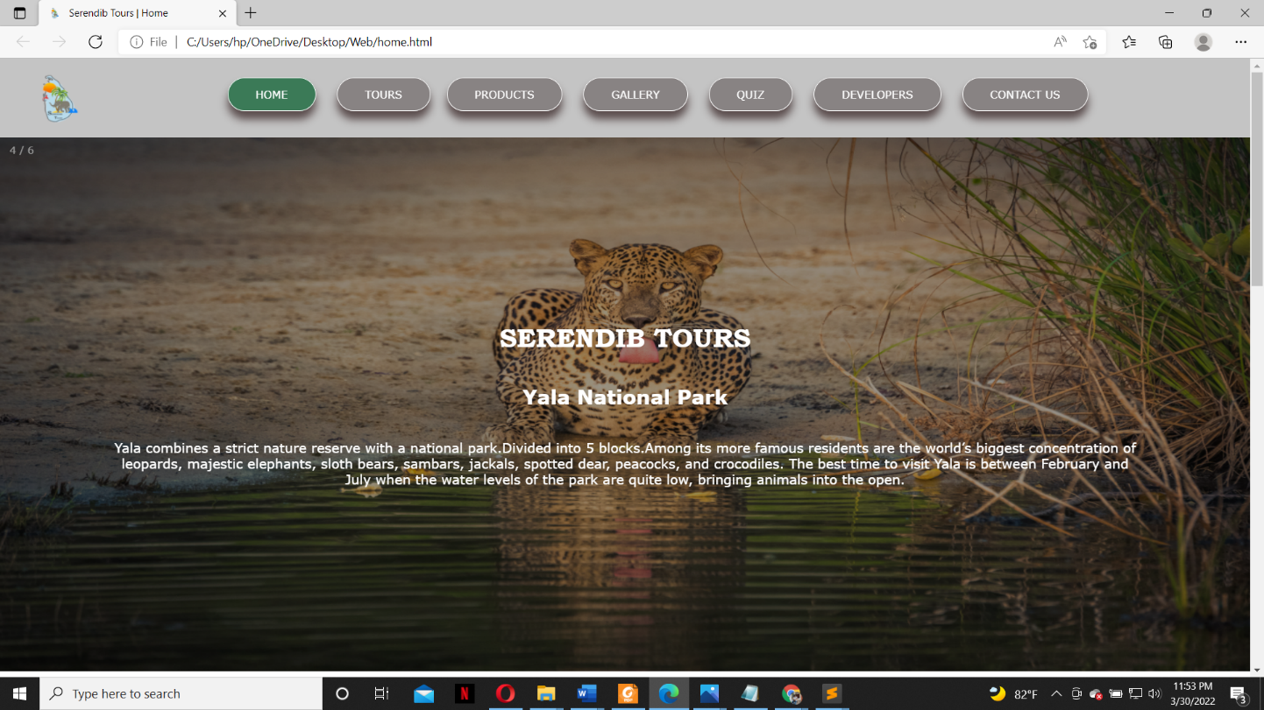

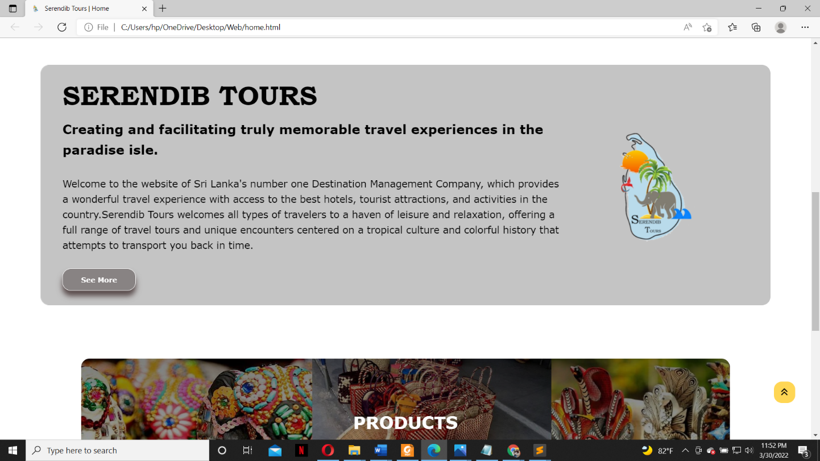

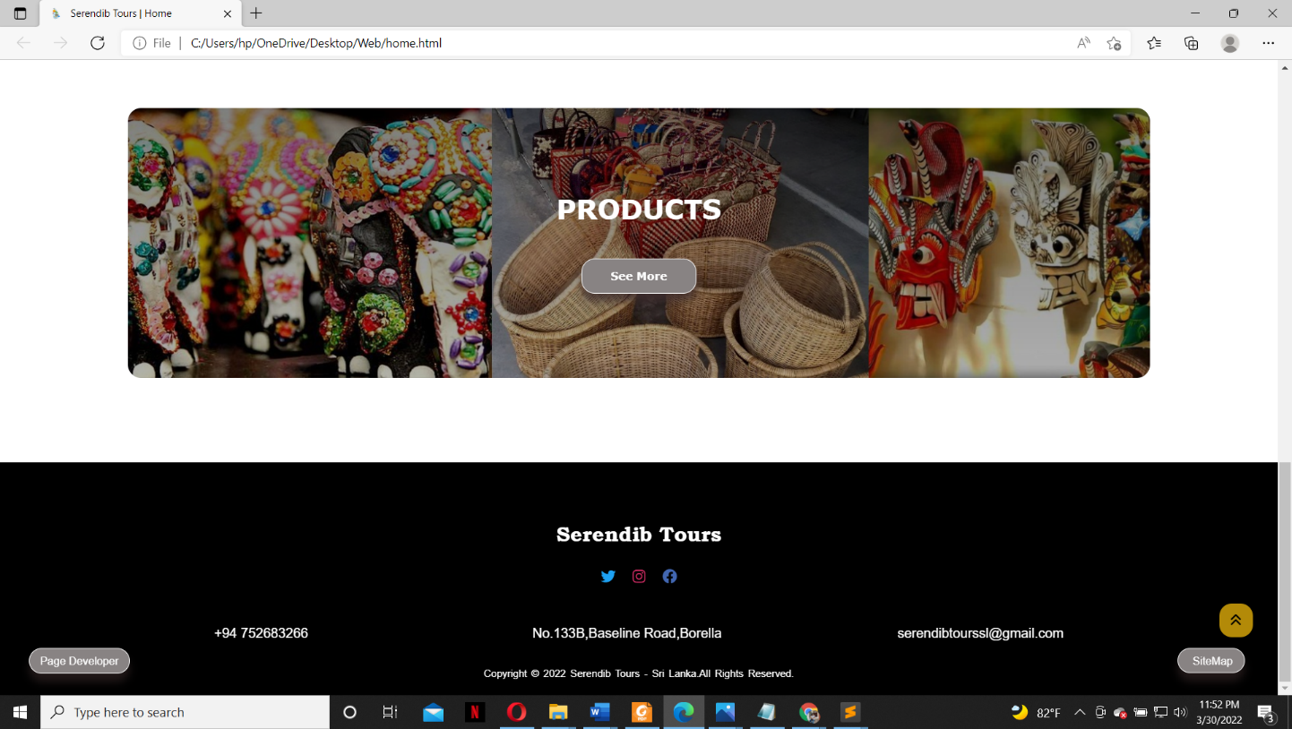

* **query.html**

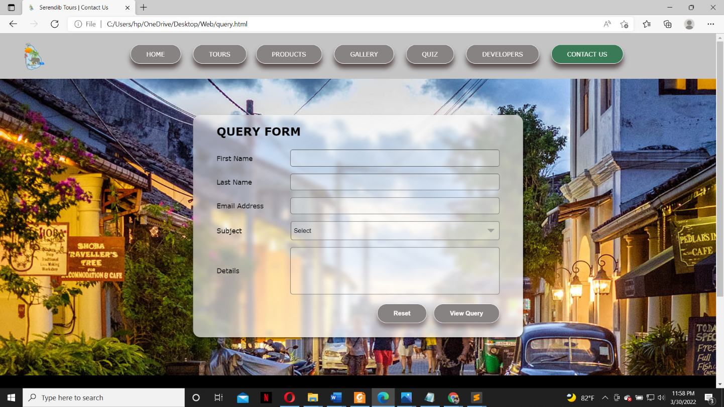

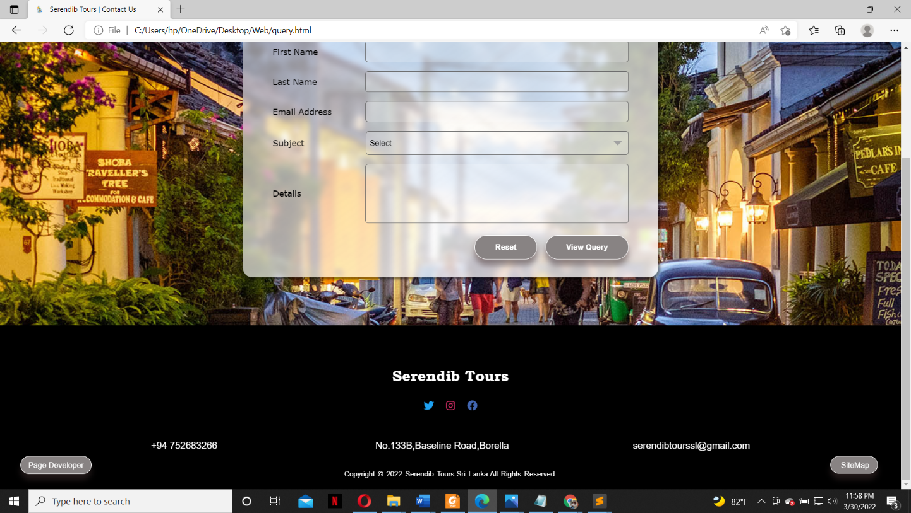

* **map.html**

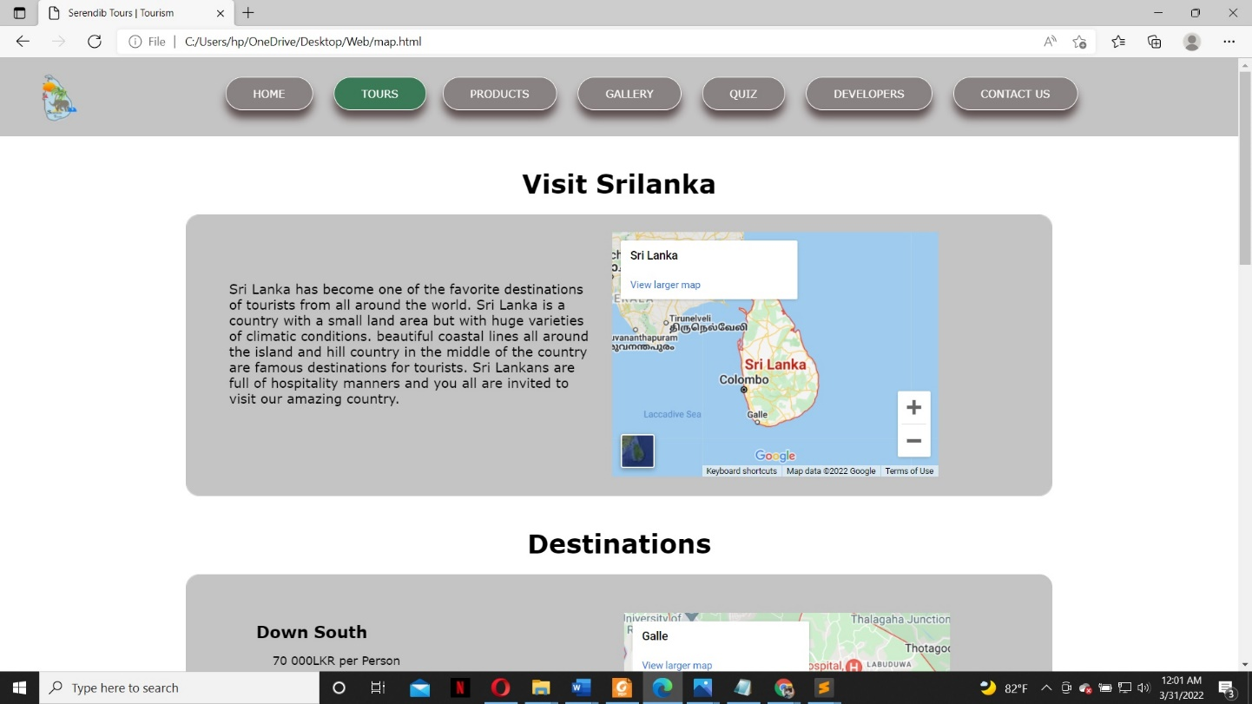

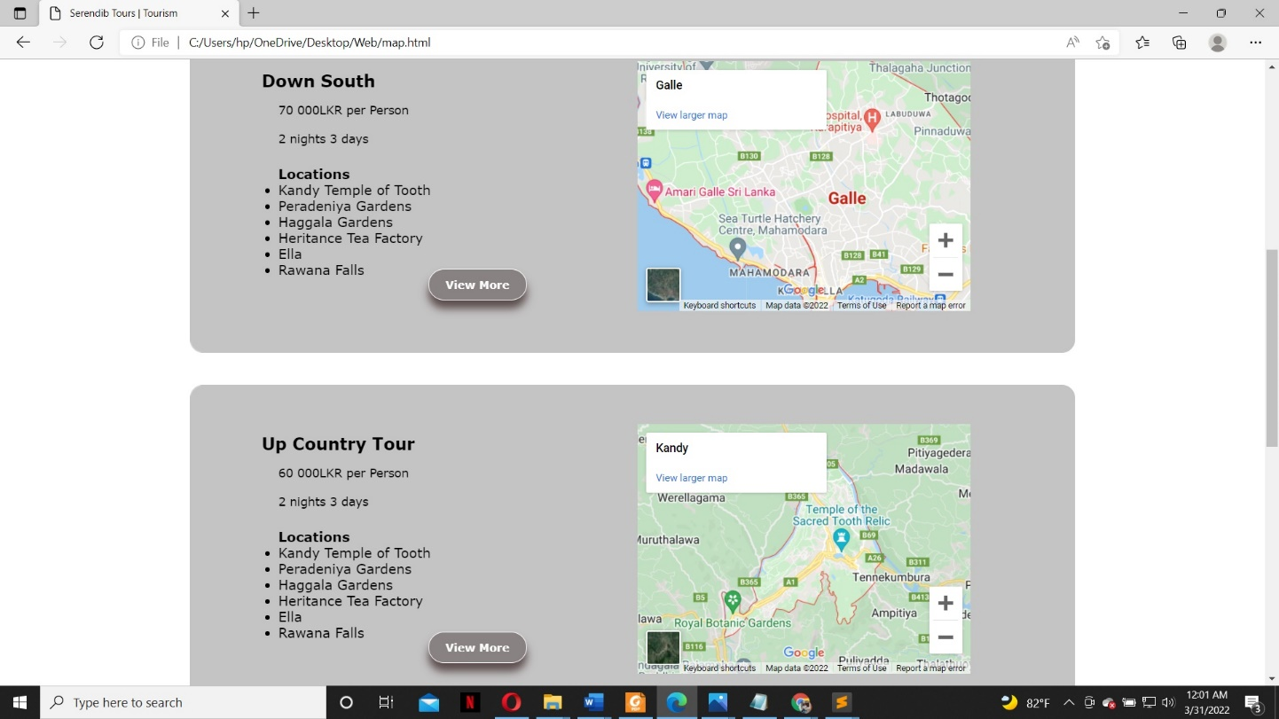

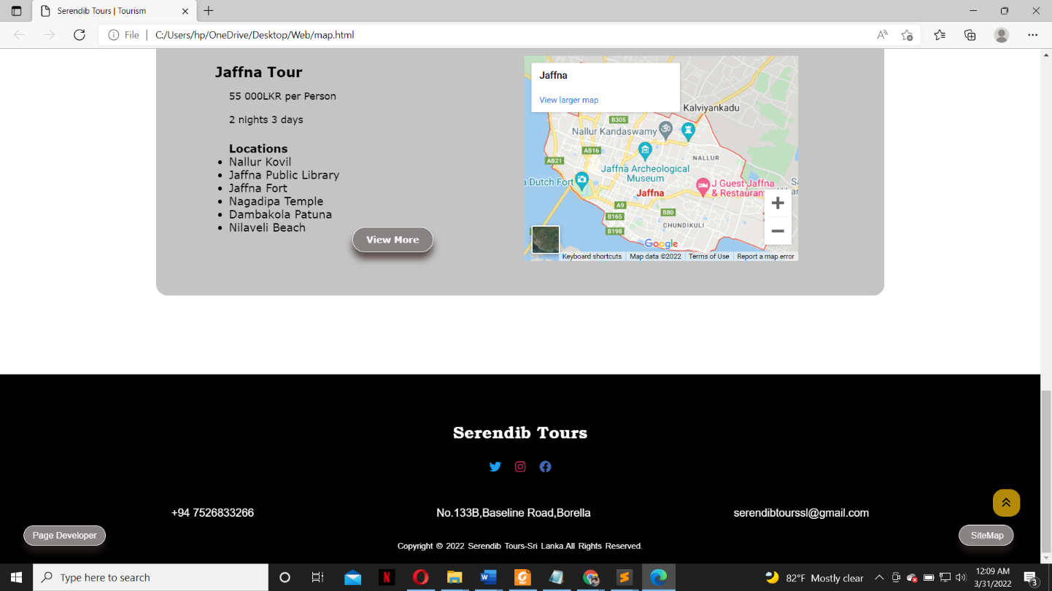

* **kandy.html**

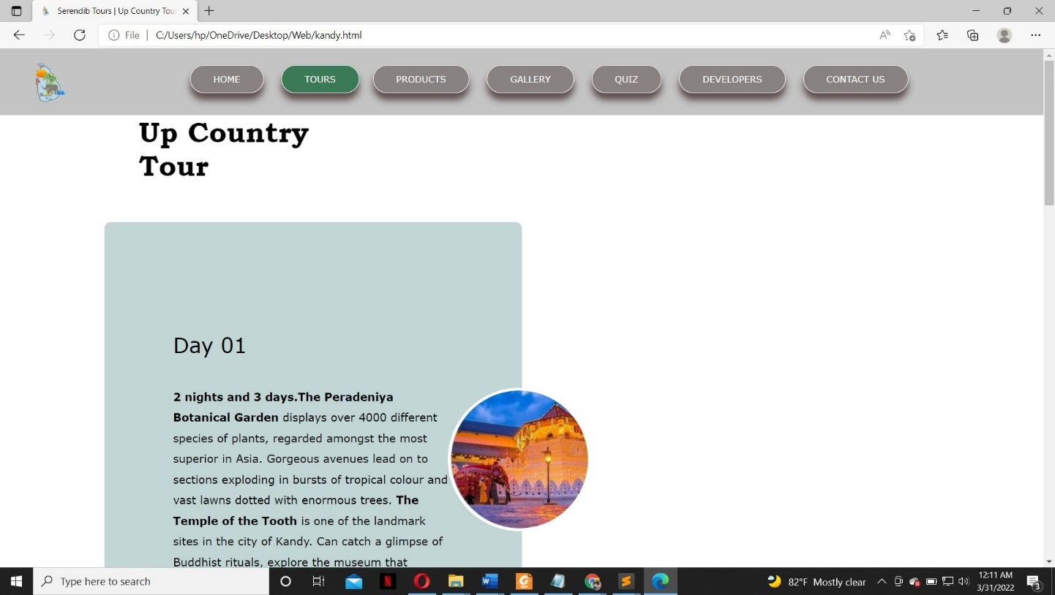

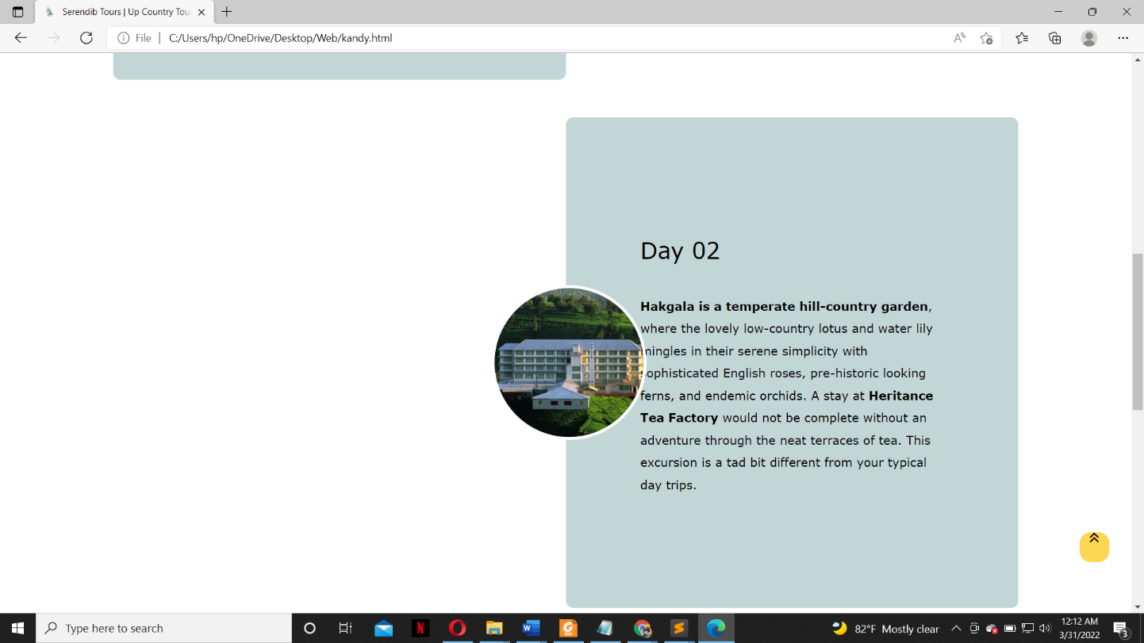

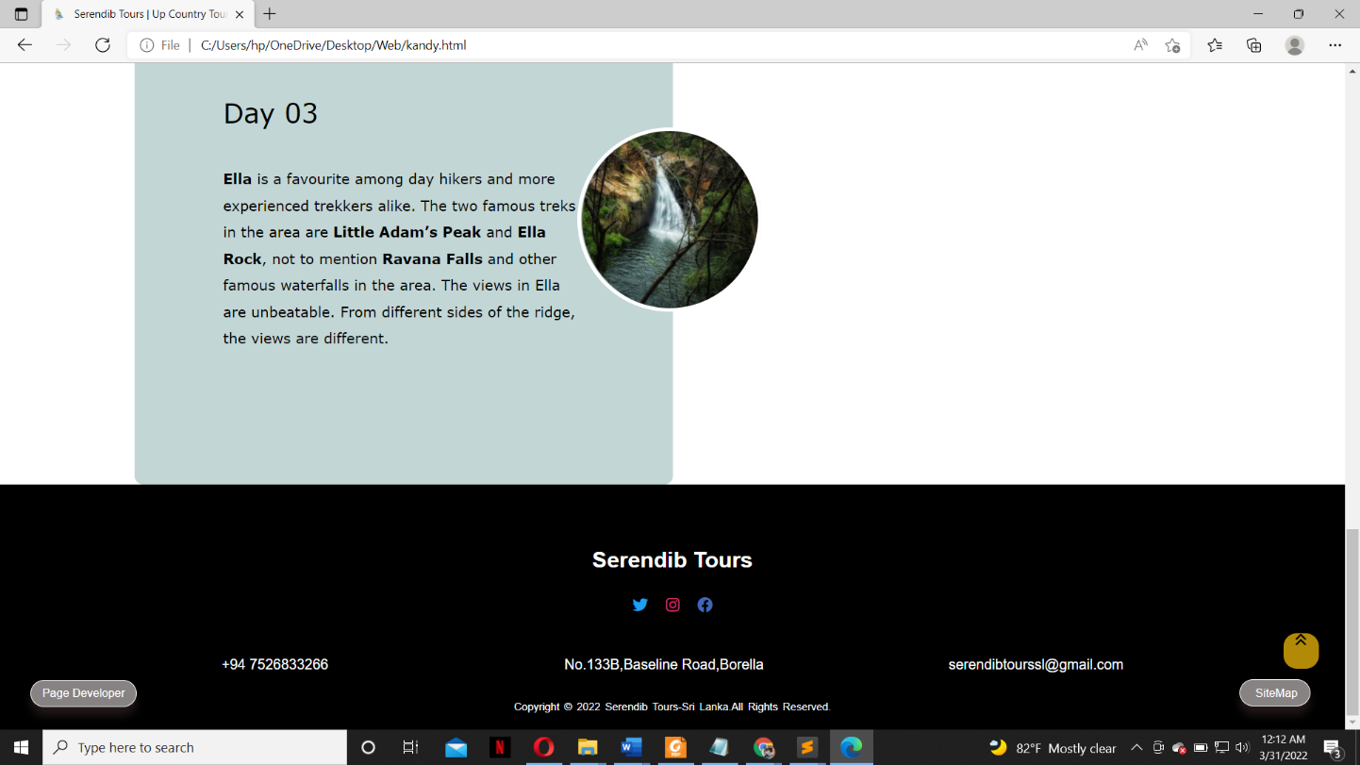

* **jaffna.html**

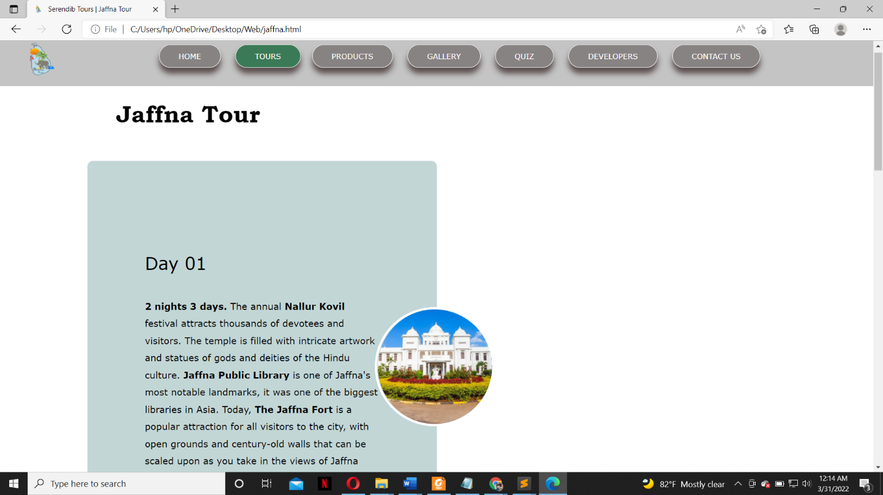

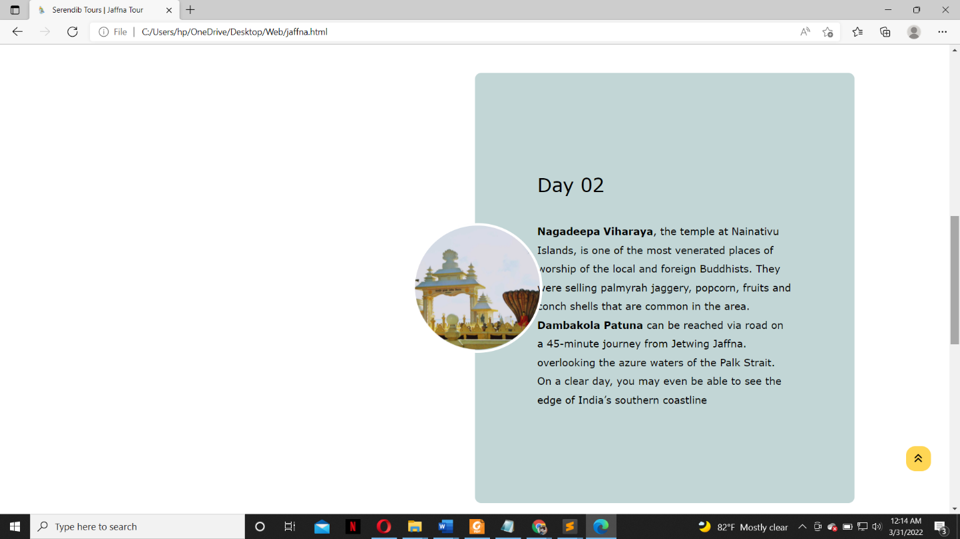

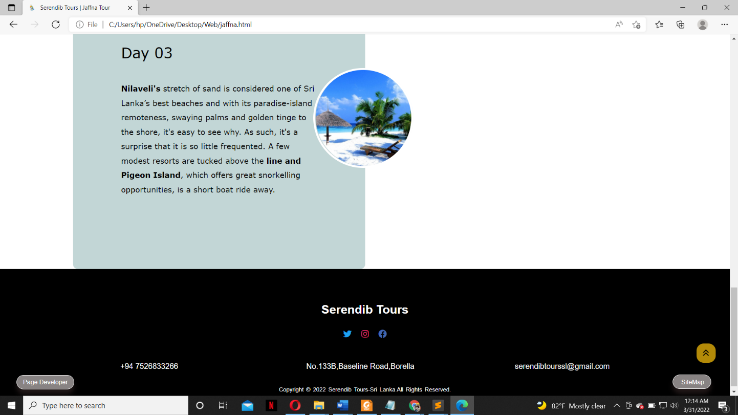

* **south.html**

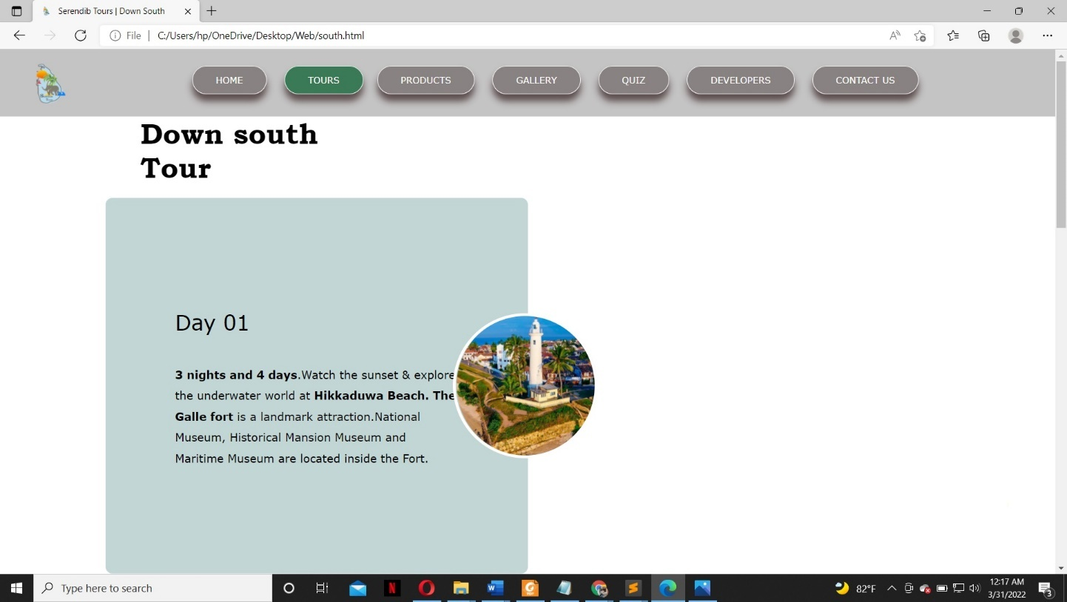

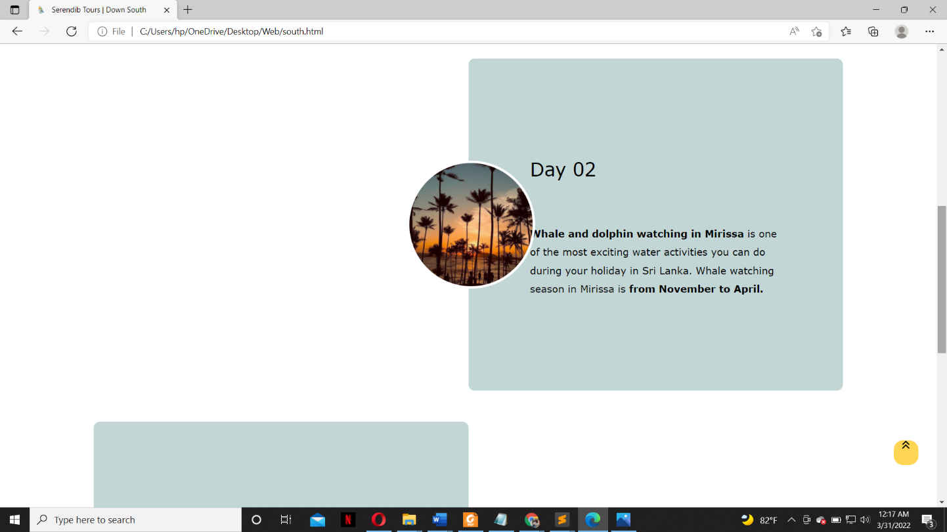

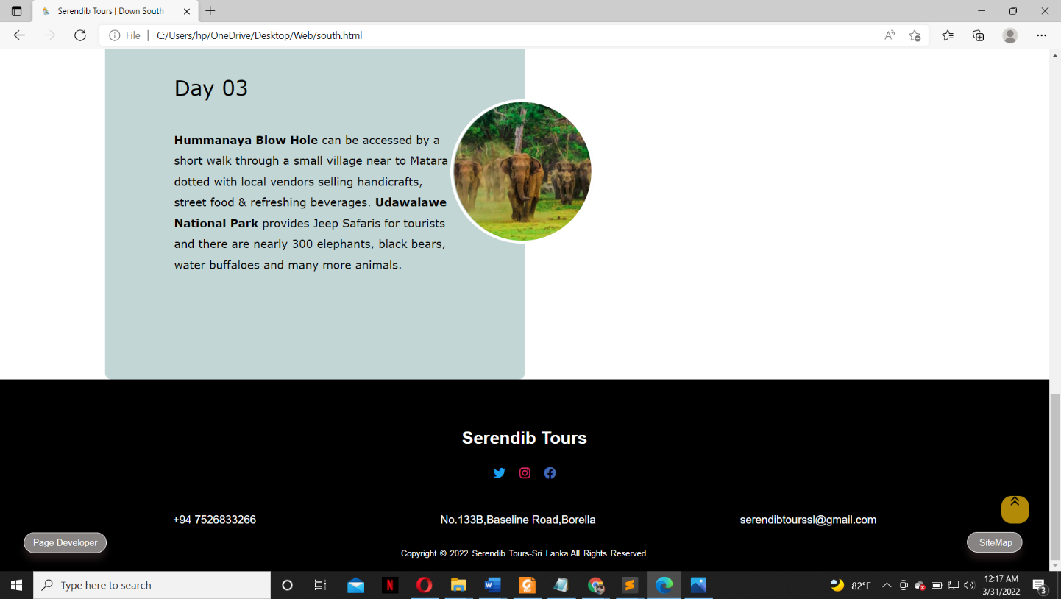

* **ilsara.html**

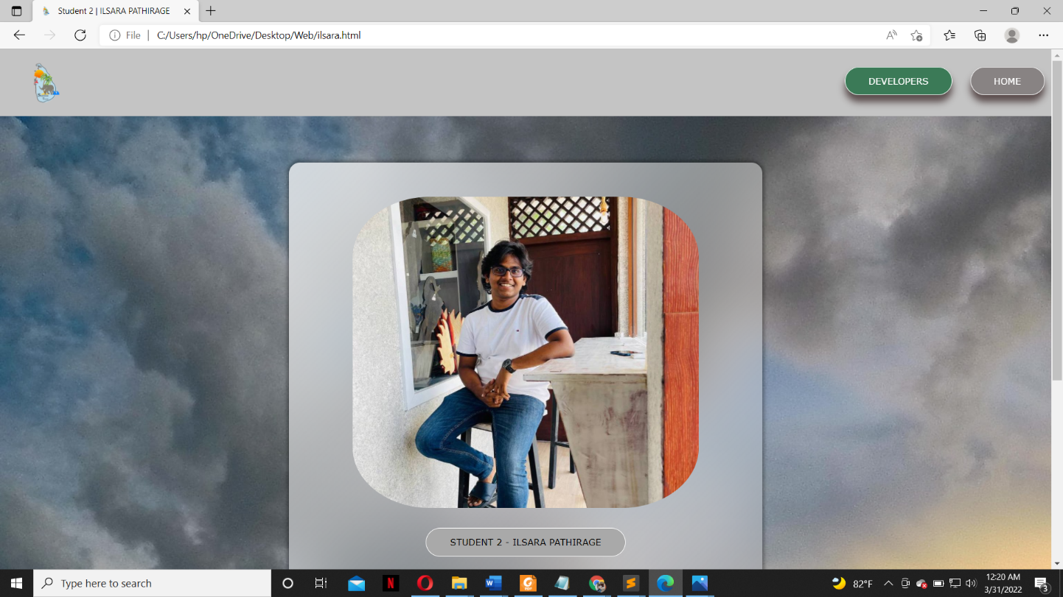

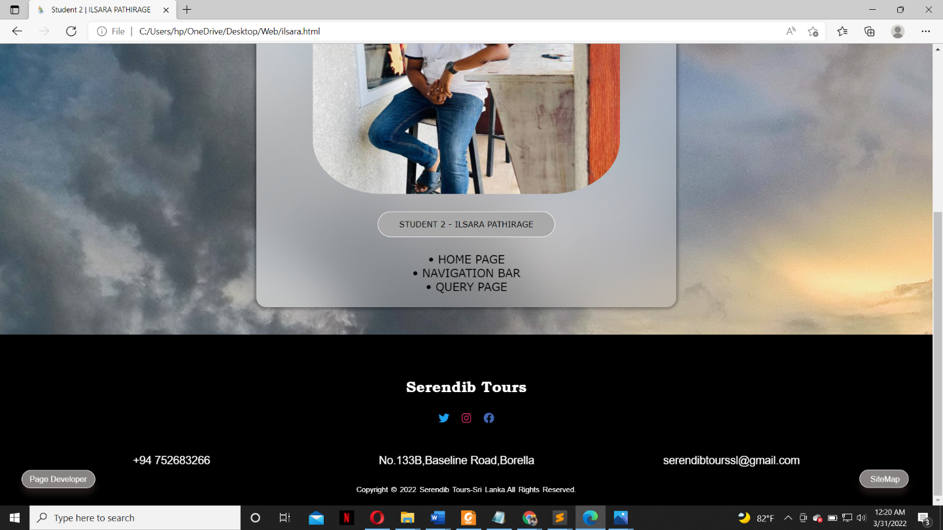

## 

## 6.3 Appendix C: Screenshots - Webpage Validation Evidence

* **home.html**

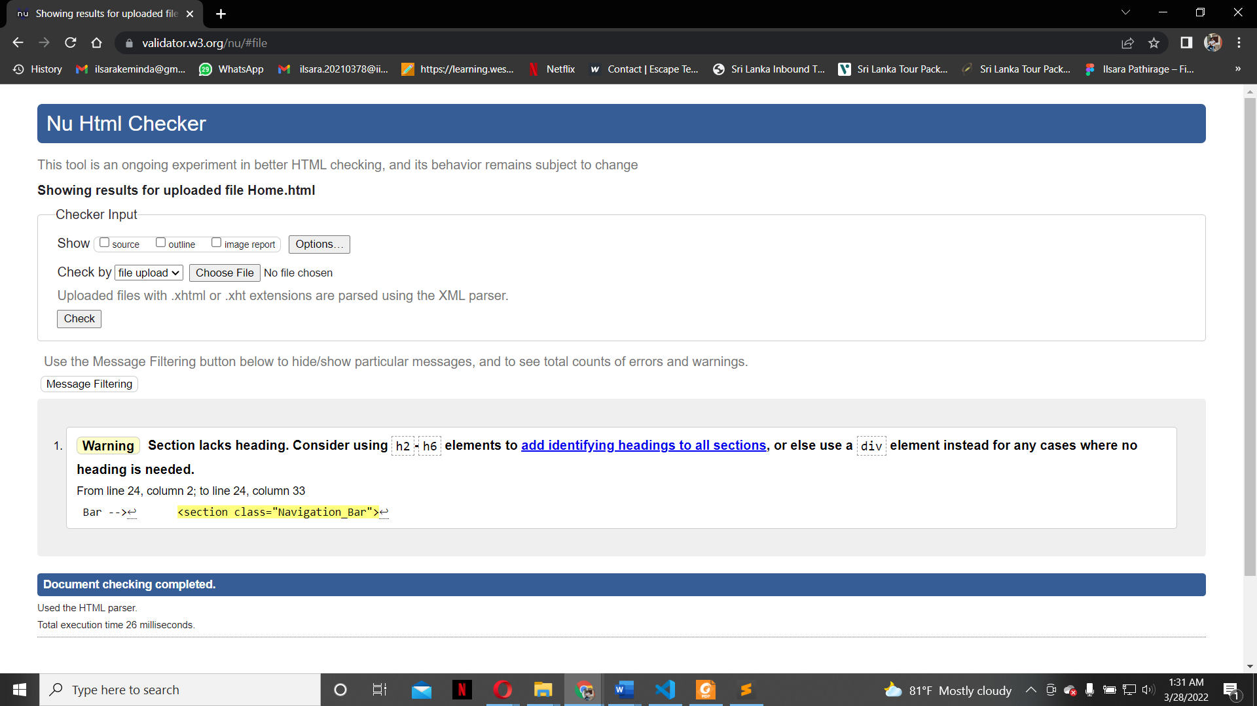

* **query.html**

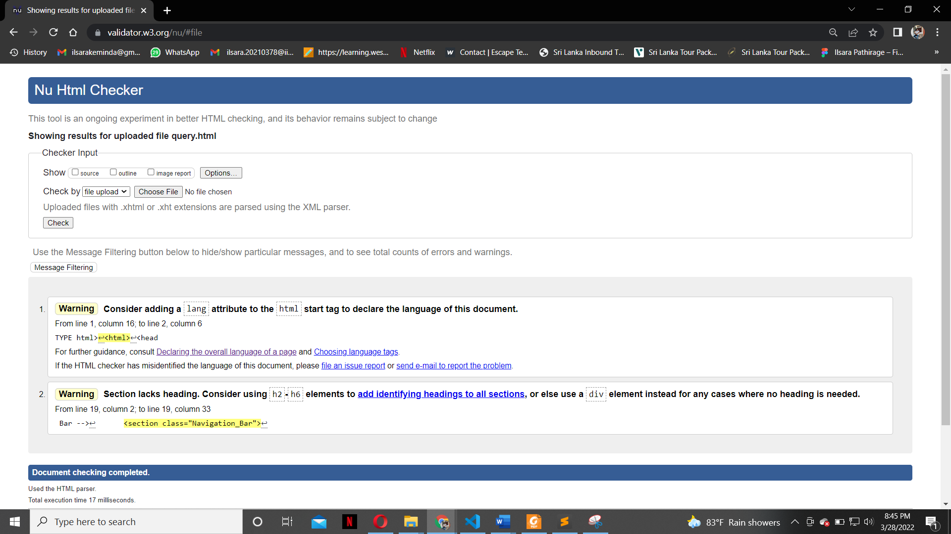

* **Ilsara.html**

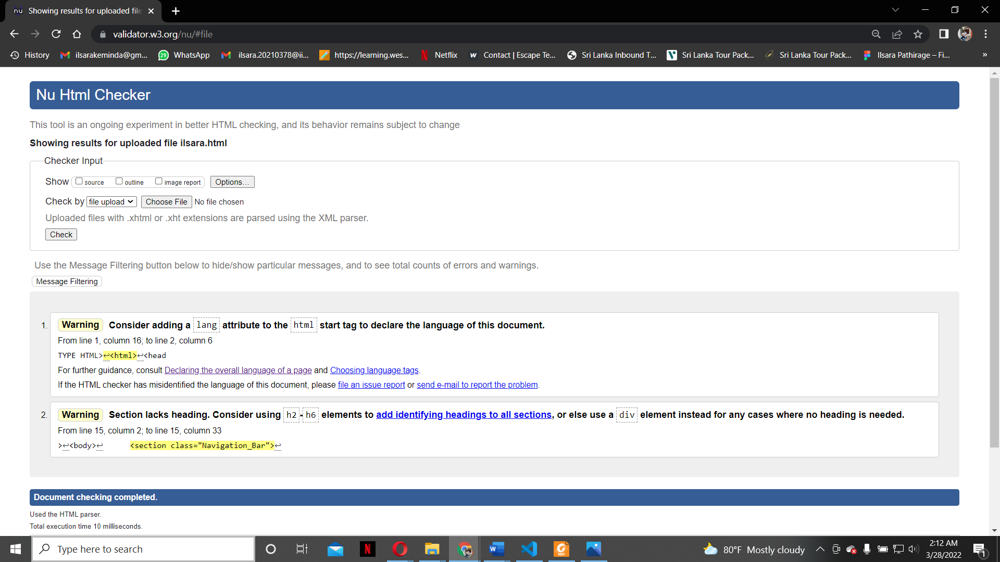

* 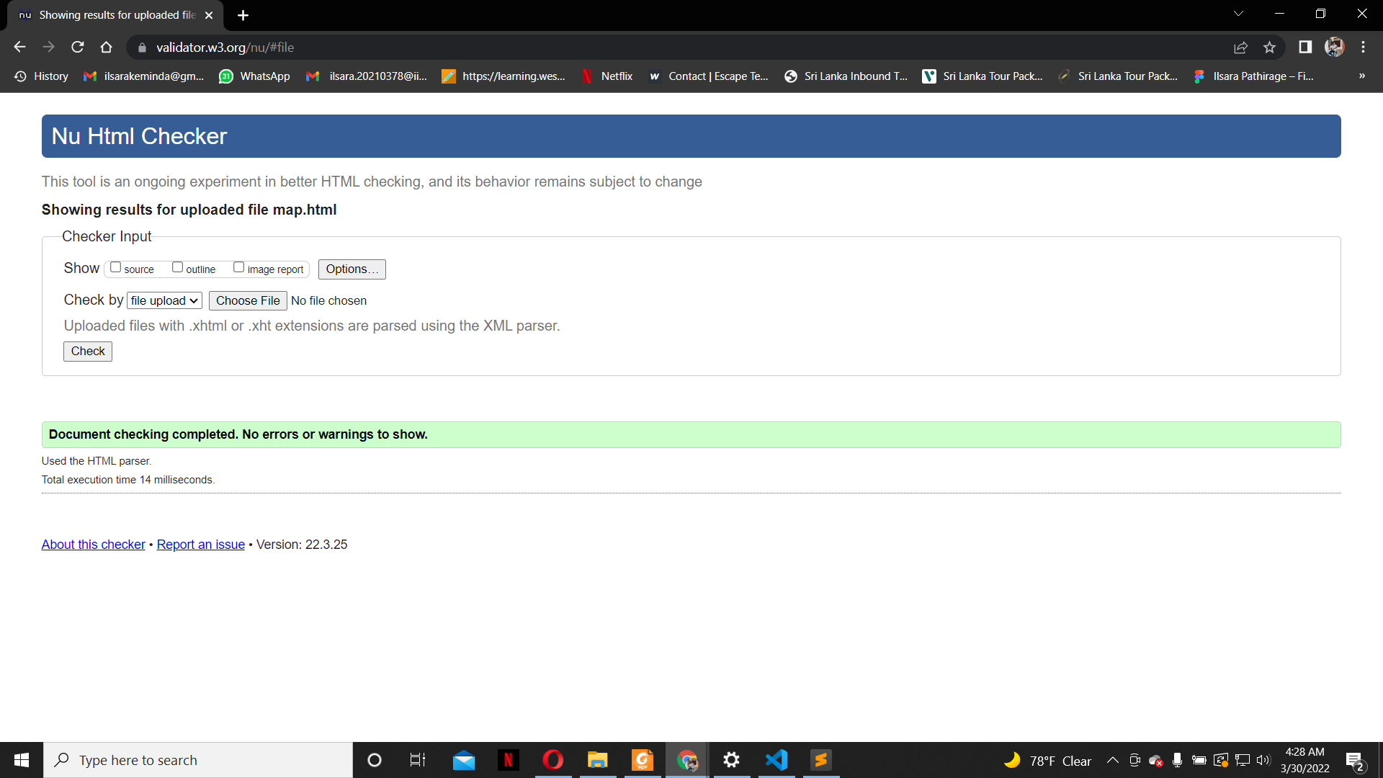**map.html**
* **jaffna.html**

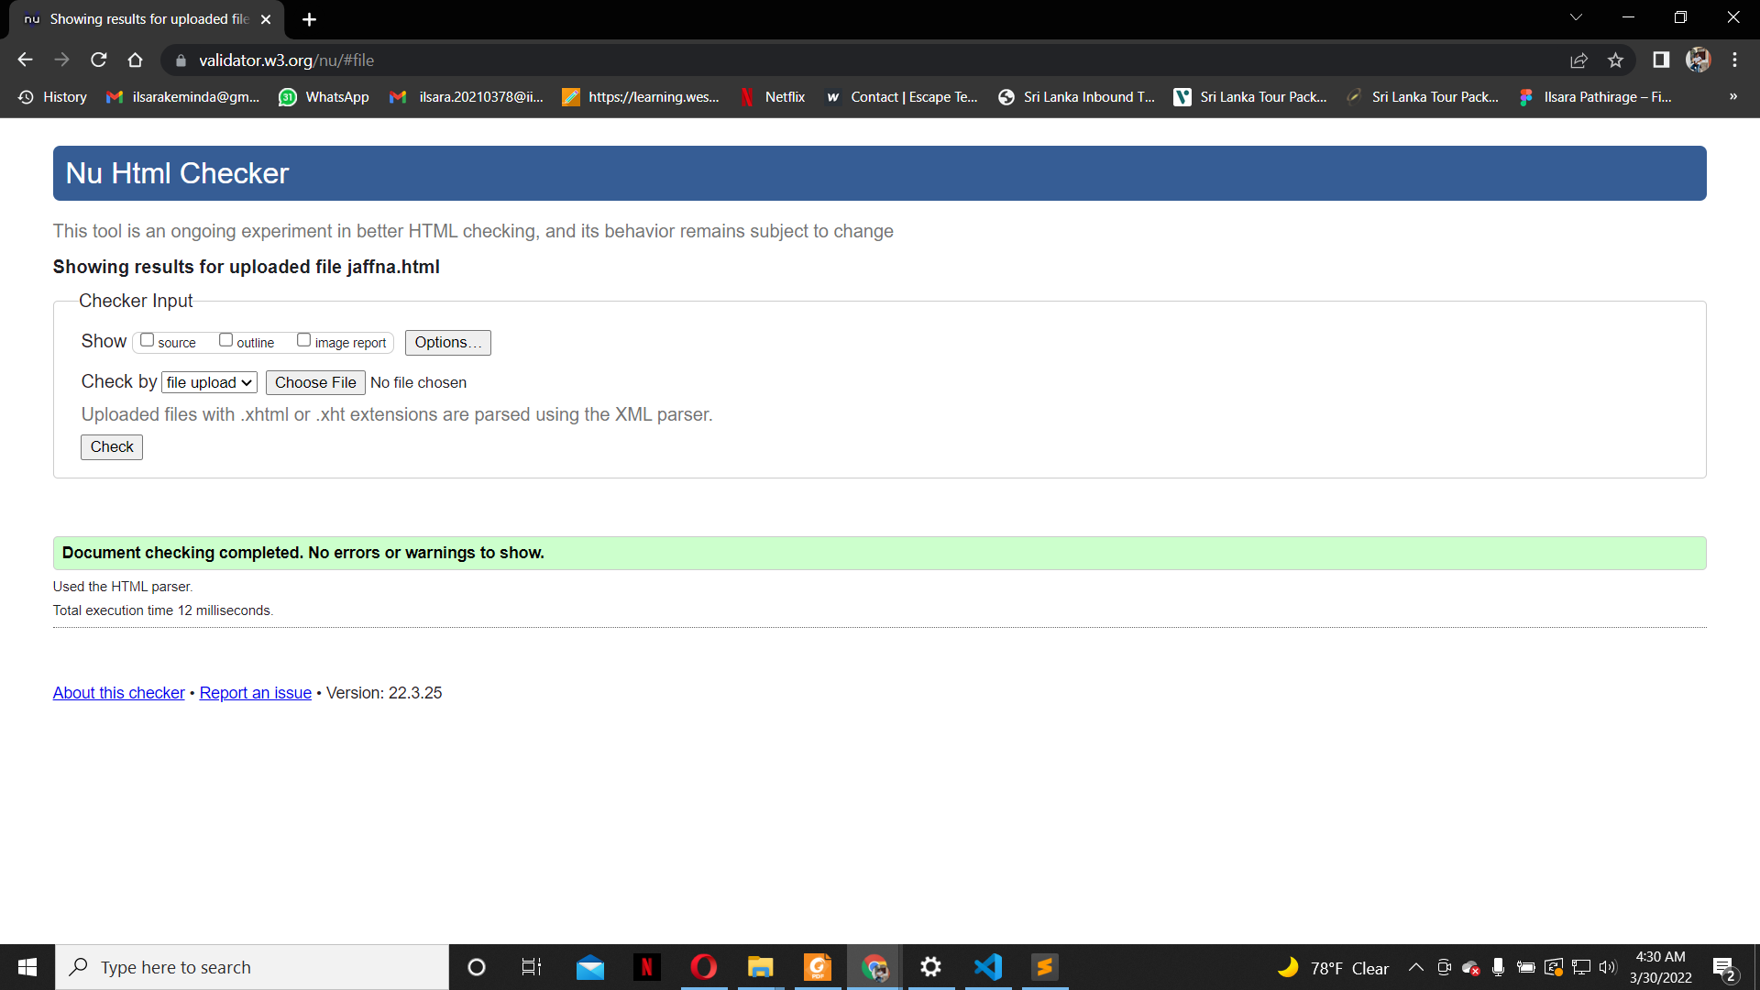

* 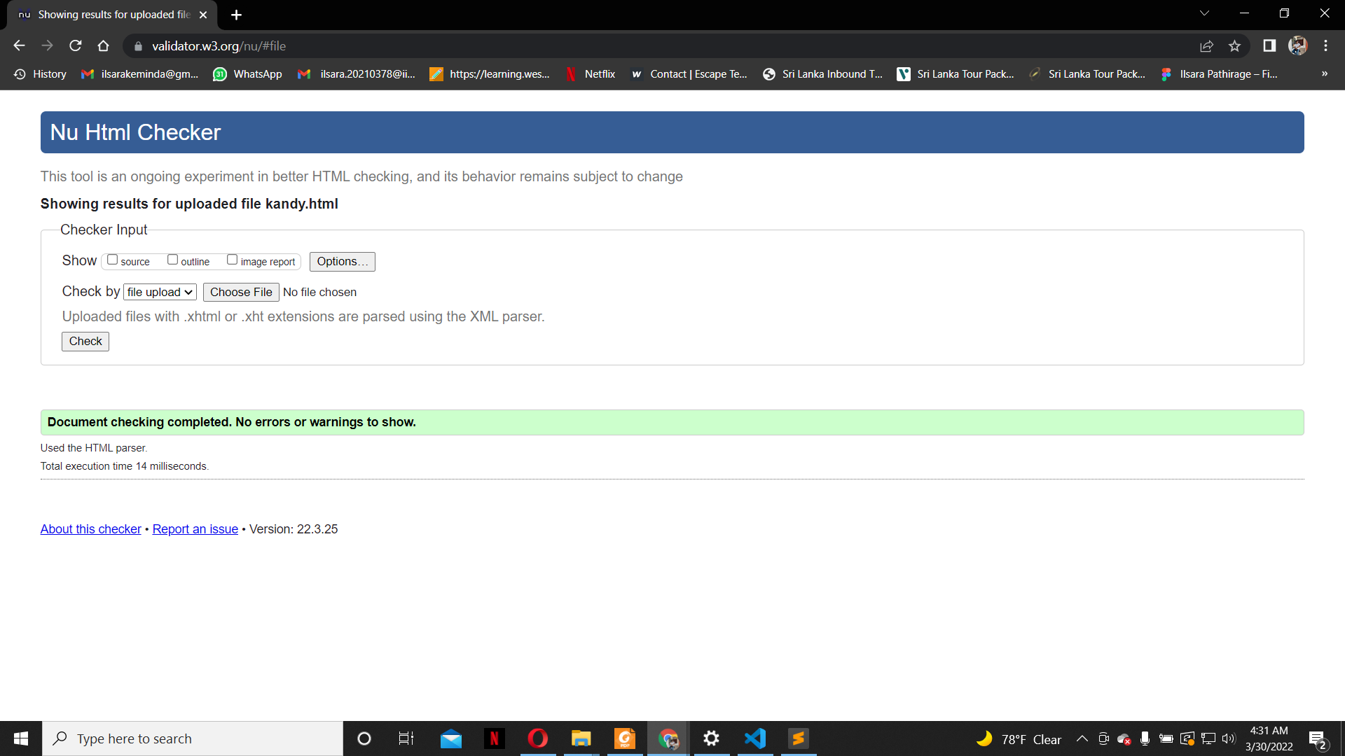**kandy.html**
* **jaffna.html**



## 6.4 Appendix D: Individual Statement

| Student Name: | Ilsara Malavi Pathirage | Student Id: | w1867461 |
| --- | --- | --- | --- |
| State what tasks you carried out in the project. | | | |
| * I took student 2 role and carried out the coursework beyond my given specification to make the website more user-friendly. I was given home page, query page and editor page. I have linked all the html files to the navigation bar. | | | |
| State what you enjoyed and did not enjoy about teamwork. | | | |
| * Enjoyed: Separating tasks to group members and working as a group * Not enjoyed: We couldn’t be able to meet physically. | | | |
| State what you learnt about teamwork. | | | |
| * Every individual doesn’t have same skill. We must respect to their talent and help them | | | |
| State what skills you gained/learnt from undertaking the project. | | | |
| * Leadership Skills * Make the whole team to success * Time management | | | |
| State any strengths about yourself that emerged whilst undertaking the project. | | | |
| * Leadership Skills. * Have a specific vision | | | |
| State any weaknesses about yourself that emerged whilst undertaking the project. | | | |
| * Not having much knowledge in JavaScript. | | | |
| State how you would do things better if you were to undertake the project again. | | | |
| * Assign tasks according to students’ capacity and knowledge. * I would try to manage time much in next time. | | | |
| Additional general or project specific comments: | | | |
|  | | | |
| Student Signature | Ilsara Malavi Pathirage | Date: | 31/03/2022 |